**School of InfoComm Technology**

**Deep Learning**

Diploma in Data Science (DS)

Diploma in Information Technology (IT)

October 2022 Semester

**INDIVIDUAL ASSIGNMENT 2**

(40% of DeepLearning Module)

|  |  |  |
| --- | --- | --- |
| Student Name | : | Ethan Liew |

**1. Overview**  **2**

**2. Data Collection and Processing** **2**

2.1. Choice of Apps 2

2.2. Cleaning of data and converting into numeric tensors 2

2.3. Sampling of data 2

**3. Develop Sentiment Analysis Models**  **2**

3.1. Ash 2

3.2. Marcus 2

3.3. Javier 2

3.4. Ayrton 2

3.5. Ethan 2

**4. Model Evaluation using Testing Data**  **2**

4.1. Analyze different models performance using testing data 2

4.2. Compare and discuss model’s performance 2

4.3. Recommend the best model and why 2

**5. Use the Best Model to Make Prediction** **3**

5.1. How to apply the model on a real-life text input 3

5.2. Explain and analyze the model prediction 3

**6. Summary**  **3**

6.1. Summarize model performance and provide suggestions for further improvement 3

# 

# Overview

For this assignment, a dataset of app reviews and their respective scores based on the chosen app is provided. The dataset contains the target variable, score, which represents the number of stars out of 5 given for that app by different app users. Additionally, there is also a variable which stores the users’ reviews in words corresponding to the score they gave. With this, the objective is to build a sentiment analysis model to predict the app review scores based on the word reviews provided by the users. With this, the ability to predict the scores based on app users’ reviews will be able to give the app more exposure by analyzing the customer reviews. With being able to predict the customer review scores on the app, the app can explore the app user’s reviews that are predicted to have low app review scores. This can help the app to fix the issues brought up by the user reviews with predicted low review scores and also maintain the and update the features complemented by the app users’ reviews with predicted higher scores. Therefore, with sentiment analysis giving the ability to predict app review scores based on the app reviews, it will give the app developers more exposure to what users are unhappy with in their app and what they are satisfied with, to increase the number of users using their app.

The approach to building a sentiment analysis model is to first choose an app to extract the dataset from. The choice of app must have sufficient sample size over the wide range of scores. As users tend to only vote 1 or 5 stars, it is also important that the app chosen has a sufficient sample size for 2,3, and 4 stars as well. This ensures that the sentiment analysis model builds cover the whole range of app review scores and not just the extreme ends. Therefore, the choice of app must be quite popular to ensure that each category of app review score is sufficient for both the training and test phase when building the sentiment analysis model. After choosing the app, the app reviews and the corresponding app review scores have to be extracted into a dataset so that it can be trained and tested on. This is also known as data collection which is crucial when it comes to building sentiment analysis models.

After data collection, data processing is performed. When it comes to sentiment analysis, data processing is crucial as it helps to prepare the text data for analysis and ensure that the results are accurate and meaningful. The goal of data processing is to clean, preprocess, and transform the text data so that it can be easily analyzed by algorithms. The quality and structure of the data can have a significant impact on the results of the sentiment analysis, so it is important to ensure that the data is processed correctly. For data cleaning, it involves removing any irrelevant information, correcting errors, and ensuring that the data is in a consistent format. Additionally, it is important to eliminate any noise in the data that may negatively impact the analysis, this can be in the form of removing irrelevant information like words, punctuations etc. For data preprocessing, it involves converting the extracted dataset and scores into numeric tensors (X & y) as these sentiment analysis models can only process numeric data. The extracted dataset will contain the customer reviews via text, and the scores. Thus, this input into the sentiment analysis model is in a non-numeric format and hence the need to convert the text data into numeric tensors, so that the sentiment analysis algorithms can process and analyze the data more effectively and produce more accurate results. This conversion allows the algorithms to use mathematical operations on the data, such as finding patterns and relationships between words, to perform sentiment analysis. Lastly, the dataset is split into a training set, validation and testing set. The training set is used to train the sentiment analysis model while the test and validation dataset is to ensure the model can perform as well on unseen data and to indicate the presence of overfitting.

After data processing, the sentiment analysis model is trained using the training data. This is also where the different sentiment analysis models are built to find out which is the best performing one. The models could vary in terms of the layers used and the type of network it adopts (CNN vs RNN). The main approach to building the model is to start with a baseline model and gradually scale it up until it overfits. Once it overfits, overfitting treatment is then applied to regularize the model and tune the model hyperparameters accordingly. The indication of overfitting is achieved through the comparison between the training and validation loss curves which shows overfitting when the validation loss starts to increase while the training loss continues to decrease. Then, after the training phase, the created models are then evaluated using testing data to ensure that it can perform well even on unseen data, which is the whole point of a sentiment analysis model. The models’ performances are then evaluated and compared to recommend the best sentiment analysis model. Lastly, the best model is then used to make a prediction based on the user input to see if the recommended model can output the correct score based on the user.

# Data Collection and Processing

## 2.1. Choice of Apps

For the choice of the apps, we actually looked from many perspectives and different categories to find a category that will have plenty of well-known apps for us to work with. Generally speaking, if the app is more well-known, it is implied that there will be more users, which will lead to more reviews and ratings for us to work with. At the beginning, we were thinking of what apps that we will always use in our daily lives. We also decided that we should choose apps that are from the same category as the reviews would contain some similar keywords. that will help in the prediction of our models. Some apps that came to mind were Instagram, YouTube, Twitter etc, all these apps were linked to the common category of social media. Social media is also a very vague category, which means that this category is very flexible to changes and can branch out to many sub categories. After choosing the category of social media, we had to choose our apps and had to make sure that there were at least 5000 reviews for each star rating.

For the scraping of the reviews from Google Play Store for our respective apps, we had to utilize google-play-scraper. The google-play-scraper is actually a library that helps us in the scraping of information about apps from the Google Play Store, it provides a simple API for accessing data such as rating, number of reviews etc. In this case, we will be using the scraper to access the reviews of the apps that we are using. For the review function from the scraper, there are some parameters that had to be called which are “app_name”, “lang”, “country”, “sort” and “count”. For “app name”, it is just the URL of the app. For “lang”, it is the language of the reviews and for obvious interpretations, it will be set to en which is english. For “country”, it actually refers to the country code for the reviews which is set to the United States. ‘sort’ actually refers to the sorting order of the reviews, which is set to Sort.NEWEST which states that the most recent reviews will be retrieved first. And lastly, “count” just shows the number of reviews to retrieve per batch which was 200 as there are 200 reviews per page. All of the reviews were then stored under a variable called app_reviews and then converted into a Pandas Dataframe. After the app reviews are in the Pandas Dataframe, we will then convert our respective app reviews into a csv file for our individual usage for our models. We then had to check on the value counts for each star rating to ensure that every star rating had enough reviews. Unfortunately, after this procedure, we realized that some of our apps do not fulfill the minimum requirement of 5000 records per star rating, which then had us stumbling for a while. Thankfully, as we mentioned earlier that social media is such a versatile category, we could find another related category in ease. We decided to use streaming services as our choice, like Netflix, Hulu, Amazon Prime Video, as it was a category that we all felt very comfortable in as well.

For the apps that we have chosen, Ash has chosen Amazon Prime Video, Marcus has chosen Hulu, Ethan has chosen Netflix, Ayrton has chosen Facebook and Javier has chosen Spotify.

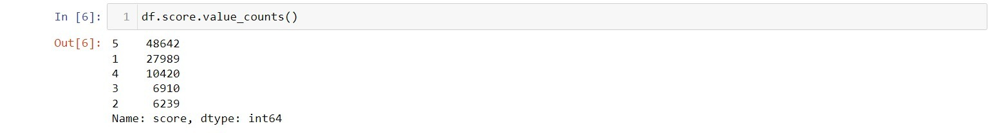

Figure 1a: Amazon Prime Video Reviews

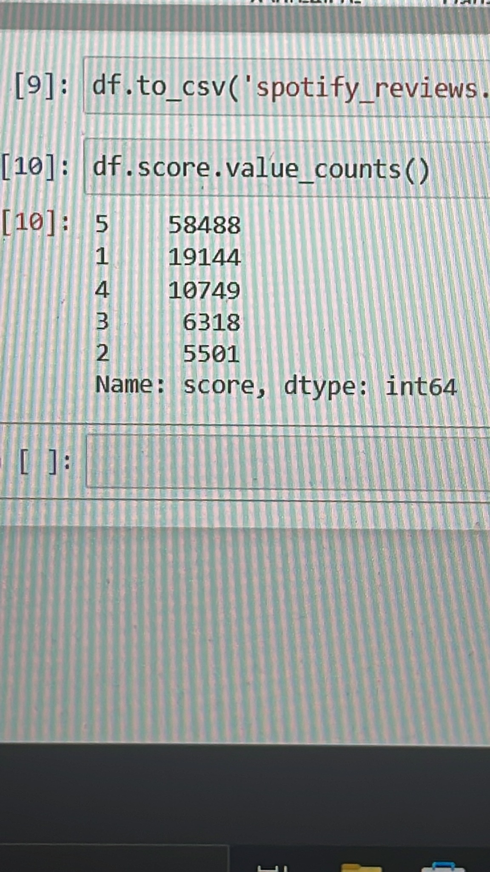

Figure 1b: Spotify Reviews

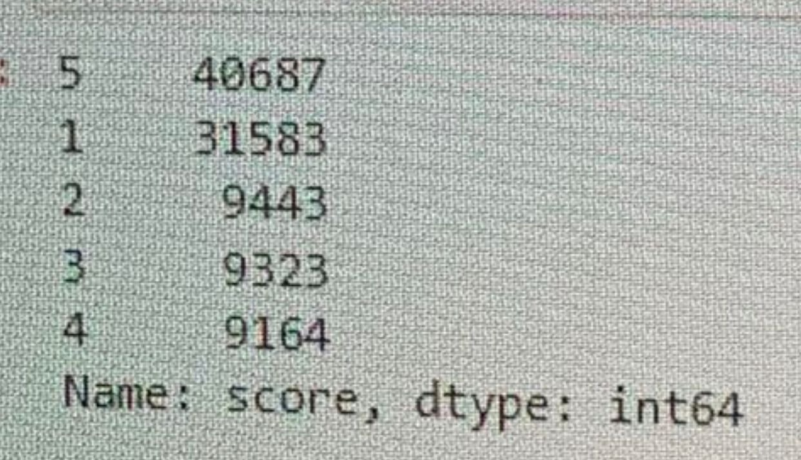

Figure 1c: Hulu Reviews

From the number of reviews that we got per star rating for each app, we decided to look at the data quality of the reviews for each app to rank them. For the data quality, we are looking at the general spread of the data for a good indicator. From the values, we can tell that the values of Hulu are more spread out as compared to the others. Hence, in this case, we would rank the apps according to how the data is spread out, as having a more evenly distributed dataset would allow for less biasness.

## 2.2. Cleaning Data

Firstly, we had to drop all the unnecessary columns that we will not need as the scraper will provide us with a default set of data with many different columns. After analyzing the columns, we felt that only the columns “content” and “score” will be important to us. Hence, we decided to drop the rest of the columns as they were very subjective on many different factors and did not really aid in the sentiment analysis prediction.



Next, we had to do the dropping of any NaNs rows so as to ensure that there are no biases in the analysis later. Missing values can introduce biases in the analysis, as the absence of data can lead to incorrect conclusions about the relationships between variables. Keeping rows with NaN values can also limit the model capability due to the longer processing time, hence by dropping these NaNs rows might also improve the overall performance of our models.



Next, we decided to make all of our characters for our reviews lowercase. By making sure that all characters are lower-cased, it helps in the general consistency of the data, as all words are then treated the same, regardless of their capitalization. Most of the sentiment analysis models actually are also trained in lowercase text data, so this will ensure that the model can learn and predict the sentiment correctly. Overall, by lowercasing every character, this will help in reducing the impact of small variations in the text.



Next, we will be handling the emojis that might be in some of the reviews of our apps. For this step, the import of the random expression (re) module has to be implemented. The re module aids us in the removal of any emoji characters from a string of text and a function named remove_emojis was created by us to tackle this. The function uses re.compile to compile a regular expression pattern which matches some sequences of Unicode characters that belong to various ranges of emoji characters. Then, the function uses re.sub to replace all instances of the emoji pattern, and returns the resulting string. This process will be repeated for every review till all of the emojis characters have been removed from the “content” column.

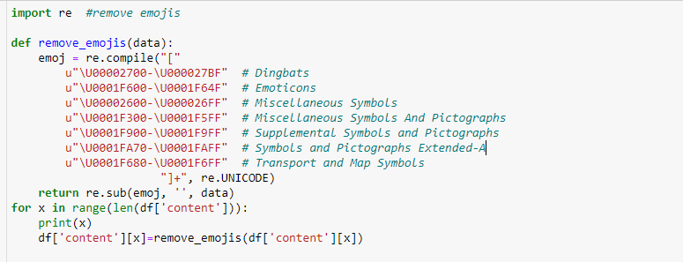

We also decided to remove numbers from the reviews.



Next, we also decided to replace various characters and also expand out some of the common contractions that are used. For example, we decided to replace all occurrences of the comma (“,”) with an empty string. And for the contractions, we also decided to replace the single quote in the contractions (“ ‘ “) like (don’t) to the expanded form (do not). This just helps in the standardization of the text and makes it generally easier to process.

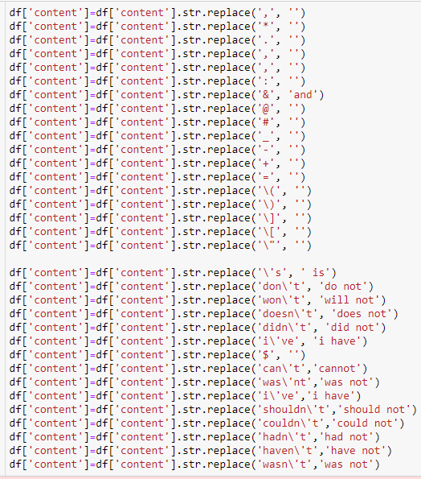

Next, we decided to do some text preprocessing. Firstly, we replace various punctuations and special characters with empty strings or a space. The code then imports the punkt package from nltk library in order to aid with the tokenizing of text. We then decided to use the stopwords corpus also from the nltk library to get a list of the common English stop words. Stop words are common words that are unlikely to provide any meaningful information and we should hence remove it during the preprocessing process. However, we decided to leave out a few exceptions of words that we do not want to remove like “don’t”,”should” etc. Finally, by using the word_tokenize function,it aids in the tokenizing of text in each row of the ‘content’ column and removes the stop words. The remaining words are then joined together with a space to form the finalised sentences and is then rewritten to the ‘content’ column in the dataframe.

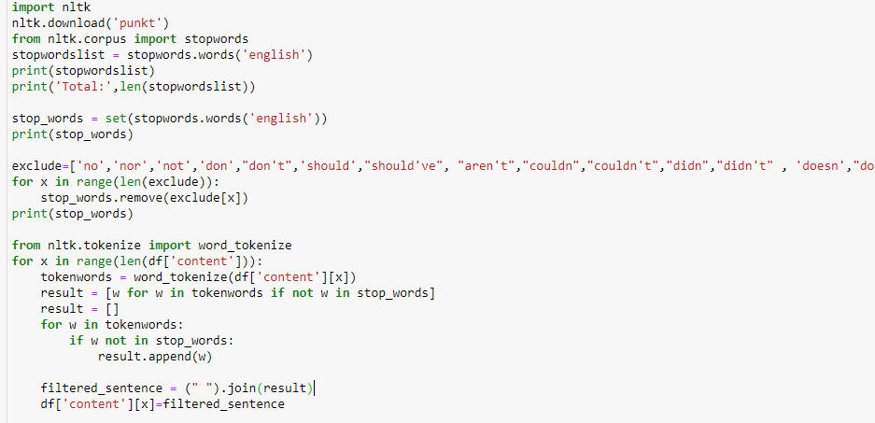

Next, we had to do some language detection. For simpler understanding, we decided to only keep all the rows that are in the English language. By importing the langdetect library, it aids us in deciding whether that row of data is in English or not. We also made a additional code of “DetectorFactory.seed=0” to set the seed for the random number generator so that the language detection results are consistent across multiple runs.

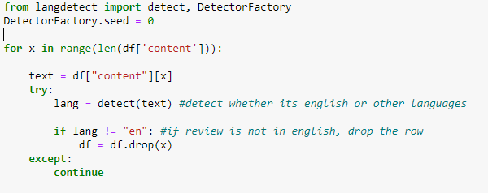

And lastly, we did a spelling correction check for any spelling errors in the text, using TextBlob.correct(). The corrected text is then returned as a string and assigned back to the same column in the dataframe. For this function to work, it is also only available for words in the English language, which is why the previous step was necessary as well.



## 2.3. Sampling of data

After the data has been cleaned to remove the unwanted noise that might provide inaccuracy to the predictions and converted into numeric tensors so that it can be analyzed by the model, the data has to be sampled to create our training, test, and validation datasets. However, before that stratified sampling is performed on the dataset. In stratified sampling, the sample is divided into multiple strata, or subgroups, based on the distribution of the sentiment labels. The sample is then selected in a way that ensures that each stratum is represented proportionally to the distribution in the population. This helps to prevent biased results, as the sample will be representative of the entire population and will contain a similar distribution of sentiment labels. For example, if the population of text data has a 50-50 distribution of positive and negative sentiment labels, a stratified sample would also have a similar distribution. This ensures that the sample used to train and test the sentiment analysis algorithms is representative of the population and that the results are not skewed towards a particular sentiment label. Hence, stratified sampling is important in sentiment analysis because it helps to ensure that the sample used to train and test the sentiment analysis algorithms is representative of the entire population of text data. This is particularly important in sentiment analysis because the distribution of sentiment labels, like the 5 different types of app review scores, in the data are uniform. For example, most apps have more 1 or 5 stars reviews as users use this to represent either their positive or negative thoughts about the app. Therefore, it helps to ensure that the sample used to train and test the algorithms is representative of the entire population of text data, leading to more accurate and meaningful results and the stratified sampling values are dependent on the cardinality of the app reviews of the different apps.

.

## 

## 2.4. Converting Data into numeric tensors

First, we need to decide on the dimensions of the train test validation split, in our case we decided to split it in to a 80/10/10 split. We calculated the appropriate values eg. (total data * 0.8 ) and assigned them to variables training_samples,validation_samples and test_data.

Next the variables maxlen and max_words needed to be determined. maxlen is the number of words that we will consider before cutting the rest of the review out, max_words is the top number of words to be considered for the tokenizer

The code then creates a Tokenizer object, which will be used to convert the reviews into numerical sequences that can be processed by a neural network. The num_words argument of the Tokenizer is set to max_words to ensure that only the top 10,000 words are considered.



The fit_on_texts method is then called on the df['content'] to fit the Tokenizer to the data.



The resulting sequences are then converted into numerical arrays using the texts_to_sequences method.



The word_index is then extracted from the Tokenizer, which is a dictionary that maps words to their corresponding numerical representations. The code prints the number of unique tokens found.

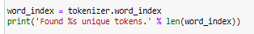

The data is then zero-padded using the pad_sequences function to ensure that all reviews have the same length.



The labels for the reviews, stored in df['score'], are then converted into numerical arrays using np.asarray.



The scores are then remapped to a new range, with scores of 1, 2, 3, 4, and 5 remapped to 0, 1, 2, 3, and 4 respectively.

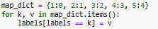

The code then shuffles the data and splits it into training, validation, and testing sets. The training set consists of the first training_samples elements of the shuffled data, the validation set consists of the next validation_samples elements, and the test set consists of the remaining elements. The corresponding labels are also split accordingly into y_train, y_val, and y_test.

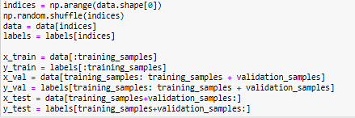

After which, the vectorized and sampled data is sampled into train, validation, and testing data. Train, validation, and test data are important in sentiment analysis because they are used to train, evaluate, and test the performance of the sentiment analysis algorithms. The goal is to use the algorithms to accurately predict the sentiment of new, unseen text data. The train data is used to train the sentiment analysis algorithms. The algorithms learn patterns in the data and adjust their parameters to minimize the error between the predicted sentiment and the actual sentiment. The validation data is used to evaluate the performance of the algorithms while they are being trained. The algorithms are tested on the validation data after each iteration of training, and their performance is used to adjust the parameters and prevent overfitting, which occurs when the algorithms become too complex and start to memorize the training data instead of generalizing to new data. The test data is used to evaluate the performance of the algorithms after they have been trained and optimized using the train and validation data. The algorithms are tested on the test data, and the results are used to measure their accuracy and determine their ability to generalize to new, unseen data. By dividing the data into train, validation, and test data, the performance of the sentiment analysis algorithms can be accurately evaluated and the results can be used to optimize the algorithms and improve their accuracy. The training to validation to testing data split that was used is 75/20/5. This means that 75% of the data is training, 20% of the data is validation, and 5% of the data is for testing

# Develop Sentiment Analysis Models (One per student)

## 3.1. Ash

For my building and training of my models, I took a very experimental approach and decided to explore many different types like TextCNN models, RNN and LSTM models. All of the models will begin with a normal baseline model, and after that, some tuning of the model’s architecture will be done like adding and removing of layers, changing of regularizations, changing of hyperparameters etc. Looking at the current problem given, it is a multi-class classification problem. This will then require the change of the output layer. The output layer should have as many nodes as the number of classes in the problem as each node would represent a class. The activation function of softmax would be used to calculate the multinomial probability distribution. This will also lead to a change in the loss-function from binary cross-entropy to categorical cross-entropy.

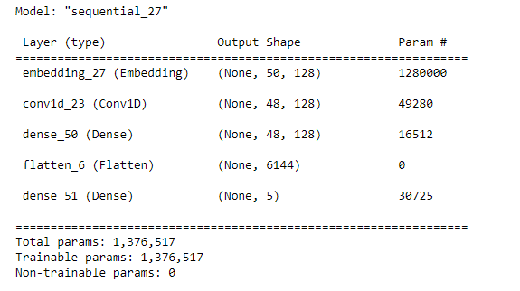

Figure 1.1: Model 1a(baseline) architecture

For my first model, I decided to design my first model with a Embedding layer first, followed by a conv1D layer, a Dense layer, followed by a Flatten layer and lastly with my output Dense Layer which will remain unchanged throughout all my models. For the embedding layer, it is used to represent the words as a vector. I will explain the specific parameters that are included in the Output Shape. For the “None” value in the shape, it is actually a placeholder for the batch size which in this case is num_words. The (50, 128) describes that each word would be represented in a 128-dimensional vector and a maximum of 50 words can be input into this layer. Next for my conv1D layer, it is meant to perform 1D convolution on the data. Afterwards, it will be a normal Dense layer followed by a Flatten layer. This Flatten Layer helps to flatten the output of the previous layer into a 1D tensor, and this is usually required before passing the data into the final output Dense layer. The final output layer will then be a Dense Layer and it outputs a tensor with shape (None,5) as there are 5 different classes for this problem.

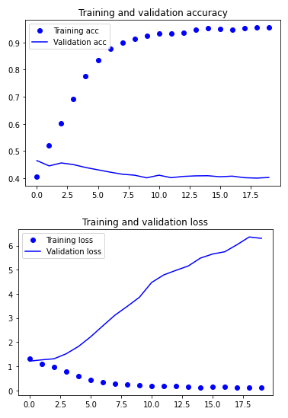 Figure 1.2: Model 1a(baseline) curves

As we can tell from the accuracy curves, this is sign of fast overfitting from epoch 3 onwards, and some methods will definitely have to be applied so as to reduce the rate of overfitting. A random fraction of neurons are "dropped out" during training using the dropout technique, which means that their activations are not taken into account. For every forward pass, this is carried out, and a random neuron is selected. Dropout aims to enable the network to learn several, independent aspects that are helpful for making predictions by preventing neurons from depending too strongly on any one feature. By decreasing the complexity of the model and requiring it to be more resilient to varied inputs, dropout prevents overfitting. For the regularizers, the process of regularization involves penalizing the loss function during training. By inserting a term to the loss function that prevents the model from fitting the training data too closely, regularization seeks to prevent overfitting. The penalty added by L1 regularization is proportional to the absolute value of the coefficients, but the penalty added by L2 regularization is related to the square of the coefficients. By pushing the model to have smaller coefficients and be less complex, these penalties aid in preventing overfitting. All of these methods will be added onto the model to prevent the overfitting rate. I ended with 95% train and 40% val accuracy.

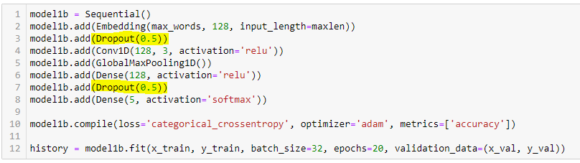

Figure 2.1 Model 1b(baseline + dropout) architecture

For my model1b, I followed a similar architecture as compared to Model1a, however with the addition of Dropout layers to aid in the slowing down of the overfitting rate. I also decided to add a GlobalMaxPooling1D layer to reduce the dimensionality of the feature maps generated by the convolutional layers. Even though this layer does not affect overfitting directly, it does help as it can simplify the model and reduce the amount of parameters that need to be learned.

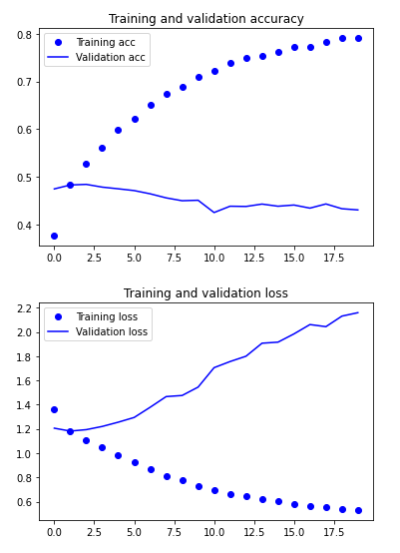 Figure 2.2 Model 1b curves

As we can tell from the curves, the addition of the dropout layers definitely aid in the overfitting as it overall reduced my validation loss drastically. However, we can still tell that there is still sign of early overfitting at around epoch 5. I ended with about 79% train and a 43% val accuracy.

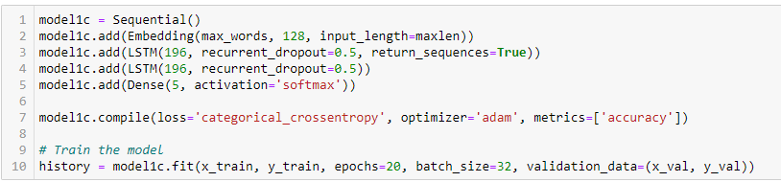

FIgure 3.1 Model 1c (LSTM with recurrent dropout) architecture

For the third model, I tried using LSTM models with recurrent dropout layers. For the first embedding layer, it is the same layer that I have previously used in the other models. For the LSTM layers, they are a sort of recurrent neural network (RNN) layer known as long short-term memory. There are 196 units in the first LSTM layer and 196 units in the second layer. The "recurrent dropout" argument specifies the dropout rate for the recurrent connections in the LSTM layer. To guarantee that the output of the first LSTM layer has the shape (batch size, maxlen, 196), the 'return sequences' option is set to True.

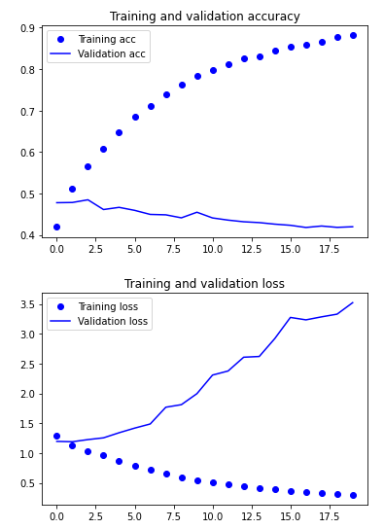Figure 3.2 Model 1c (LSTM) curves

As we can tell from the curves, it is still overfitting and the rate is actually quite similar to Model 1b. For this particular model, I decided to try using the recurrent dropout. Recurrent dropout functions eliminates connections between hidden units in the recurrent hidden layer rather than neurons in the hidden layer. The likelihood that a connection may break throughout each iteration is determined by the dropout rate. In order to avoid overfitting to the training data, connections are randomly dropped out, forcing the network to learn numerous different representations of the same input. By avoiding a overfitting and generalizing to new data, this can assist the model in learning a more reliable representation of the input data. In the following model, I will try to add regularizers to the model.

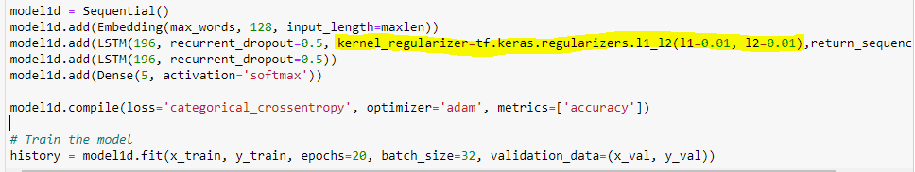

Figure 4.1 Model 1d (LSTM layers + Regularizer) Architecture

For this model, it follows the same architecture as model 1c. However for this model, I decided to use the regularizers. The kernel regularizer argument specifies a L1-L2 regularization term with regularization strength of 0,01 for both L1 and L2 in order to try and cope the overfitting issue.

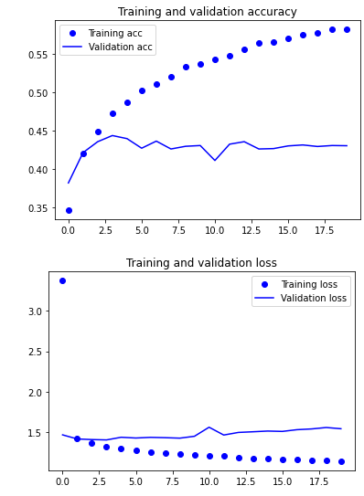Figure 4.2 Model 1d (LSTM+regularizer) curves

As we can tell from the curve, the curve is definitely much more smooth for the training and validation loss which shows that the regularizer did help.

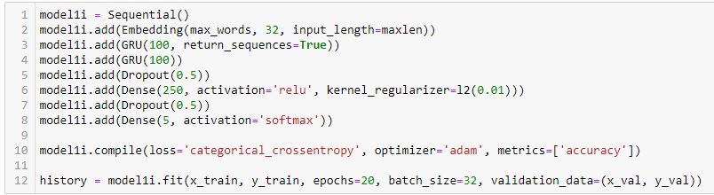

Figure 5.1 Model 1i (GRU + Dropout) Architecture

For this model, I decided to explore and use GRU layers. In order for the model to make predictions based on the data so far, the GRU layers must be able to maintain a representation of the input sequence through time and capture dependencies between items in a sequence. I also decided to add the respective Dropout layers and embedding layers exactly like my previous models.

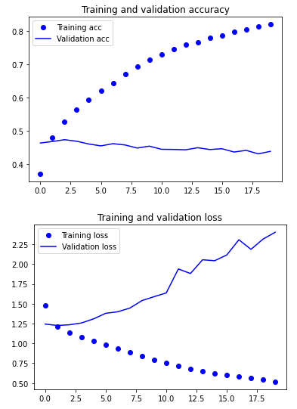Figure 5.2 Model 1i (GRU + Dropout) Curves

For this model, the curves are much more smooth and it also overfits at a slower rate as compared to the others in general.

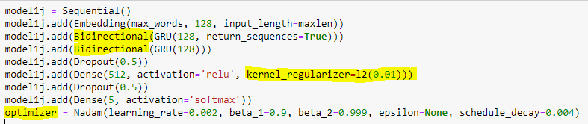

Figure 6.1 Model 1j (GRU + regularizer + Nadam optimizer) architecture

For this model, I decided to use Bidirectional GRU layers. I decided to use these layers in comparison to the normal layers as normal layers only handle one way of the input sequence. Processing the input in both directions can result in a more accurate representation of the data and higher performance when the order of the elements in the sequence is crucial. For this particular model, I also decided to use Nadam optimizer with a specific set of hyperparameters. The learning rate affects it as the model's weights are updated using this step size while it is being trained. While a bigger learning rate can speed up convergence, it also raises the risk of overshooting. A reduced learning rate causes slower convergence but helps prevent overshooting the ideal weights. For beta 1 and 2, this is actually the exponentially decay rate for the first moment (mean) estimate and second moment (variance) estimate in Adam. It establishes the importance of the gradients' uncentered variance. When the value is close to 1, past gradients are given more weight; when it is close to 0, the current gradient is given more weight.

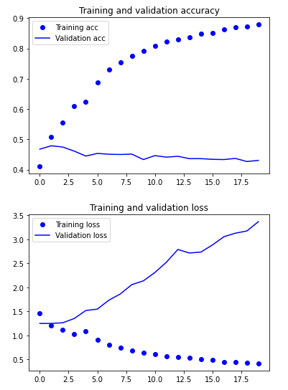Figure 6.2 Model 1j (GRU + Nadam) curves

As we can tell from this model, it actually overfits much quicker as compared to previous model, so this might show that this model is too complex and maybe the previous model was more stable.

## 3.2. Marcus

For this assignment, I am dealing with a multi-classification problem as the only inputs for score include: 1,2,3,4, and 5. This means that I will use the SoftMax activation function. This is because Sigmoid is used for binary classification methods where we only have 2 classes, while SoftMax applies to multiclass problems. For the hyperparameters, I have done between 10-30 epochs while the batch size and validation split remained constant throughout the assignment at 32 and 0.2 respectively.

I did a total of 21 models for this group assignment. First of all I wanted to test and experiment with what was taught in the practicals, these models are model1a, model1b, model1c, model1e, model1f and model1g. For model1a and model1b, I experimented with word embedding.

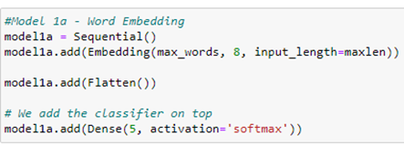

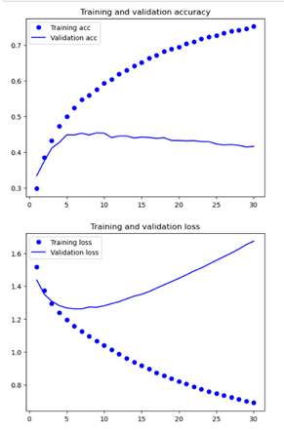

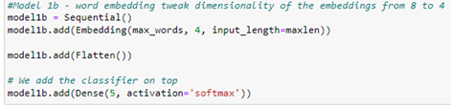

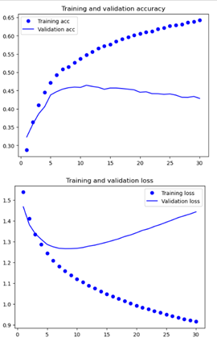

Comparing this with model1b, I tweaked the dimensionality as I changed from 8 to 4. This resulted in a decrease from 82005 to 41005 parameters in model1b. Now, I will compare the difference in loss and accuracy. For model1a, the epoch with the highest validation accuracy is epoch 9 with the train accuracy being 0.5757 and validation accuracy being 0.4539. For model1b, the epoch with the highest validation accuracy is epoch 11 with the train accuracy being 0.5471 and validation accuracy being 0.4644. However, both models started overfitting after epoch 5. From this, I can infer that having lesser parameters could help me get a higher validation accuracy.

Moving on to model1c and model1d , I did Simple Recurrent Neural Network (RNN) models. For model1c, I did not add any dropout layers but for model1d, I added dropout layers. These are the models:

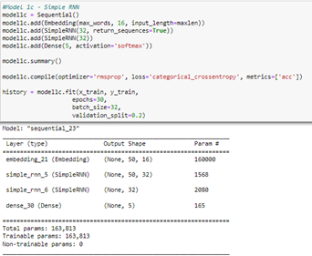

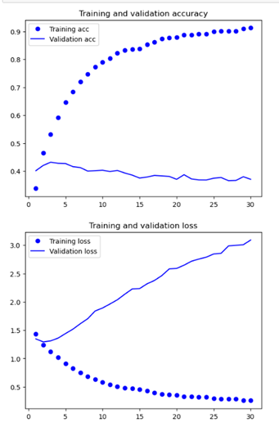

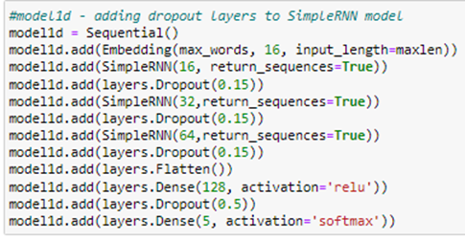

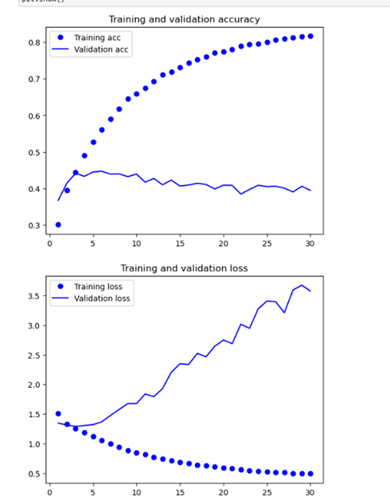

These are my training and validation accuracy graph for the SimpleRNN model1c and model1d. Compared to the other graphs, model1c has the highest training accuracy, but it is also the most overfitted model. The highest validation accuracy is 0.4319 which is at the third epoch, it also overfits at that epoch. For model1d, I added 3 dropout layers after each SimpleRNN layer. I used the dropout values of 0.15 as a large value might not help combat overfitting. I can infer from the model that adding dropout layers resulted in the decrease in training accuracy and increase in validation accuracy. The highest validation accuracy happened at epoch 6 with an accuracy of 0.4472. Overfitting happened at the epoch 4 for model1d.

Moving on LSTM layers, an LSTM layer stands for long short-term memory layer. It discovers the long-term relationships between time steps in time series and sequence data. I have used layers on the models model1e, model1j, model1p and model1s, model1t and model1u. I have created a table to compare between the models.

|  |  |  |  |
| --- | --- | --- | --- |
| Model ID | Architecture and model | Best validation accuracy, which epoch | Overfit at which  epoch |
| model1e |  | 0.4767,7th | 6th |
| model1j |  | 0.4722,3rd | 3rd |
| model1p |  | 0.4725,4th | 4th |
| model1s |  | 0.4647,2nd | 2nd |
| model1u |  | 0.4714,2nd | 2nd |

From these models, I can infer that model1e had the best model out of the models that utilized LSTM. For model1s, I used batch normalization,which is a method for training very deep neural networks that normalizes each mini-contributions batch to a layer. As a result, the learning process is stabilized, and the quantity of training epochs needed to train deep neural networks is dramatically reduced. I also used bidirectional where the output layer can get information from past and future states simultaneously. From the models, I can infer that batch normalization did not help improve the validation accuracy. There was only a slight decrease from the best LSTM model of 0.0042.

Now, I will be talking about the models with GRU layers. These models include model1f, model1h, model1k, model1m.

|  |  |  |  |
| --- | --- | --- | --- |
| Model ID | Architecture and model | Best validation accuracy, which epoch | Overfit at which  epoch |
| model1f |  | 0.4786,  8th | 8th |
| model1h |  | 0.4367,14th | 10th |
| model1k |  | 0.4717,  2nd | 3rd |
| model1m |  | 0.4722,  3rd | 4th |

From this table, I can conclude model1f has the best model, having lesser parameters helps combat overfitting. Apart from this, having bidirectional GRU layers made it overfit faster and having more layers decreased the validation accuracy as well.

From these two tables, for my datasets, doing many overfitting treatment such as normal dropout layers, regularization, bidirectional and even batch normalization did not help me combat overfitting.

Apart from these models, I even tried doing LSTM layers with GRU layers and Conv1d, conv1d with GRU layers. However, these models did not perform at all.

## 3.3. Javier

For building and training the sentiment analysis models, different parameters are changed and fine-tuned to investigate its effect on the models’ performances and accuracies.Some of these parameters can include the type of optimizers used, how deep the layer is, the number of nodes for each layer, the learning rate of the optimizer used, and the type of activation function used, to name a few. All of these are decided and adjusted based on the type of problem, the performance of the model, and how much it overfits.

Since this is a sentiment analysis problem, it can also be labeled as a multi-label classification problem hence, the last layer, being the classifying layer, would have to contain the softmax activation function, which transforms the raw outputs of the neural network into a vector of probabilities, essentially a probability distribution over the multiple input classes. With softmax, we are able to return an output vector containing probability scores of each label that is N entries long, where N represents the number of labels, which is 5 to represent the 1,2,3,4,5 stars that an app review score can be classified as. Based on the vector of probability scores, it gets the predicted app review score of the highest probability.

Apart from using softmax activation function, because the model is tackling a multi-label classification problem, it will be using categorical entropy as the loss function. The categorical entropy loss function assigns a unique integer value from 0 to the number of classes -1, which then calculates the average difference between the actual and predicted probability distribution for all app review scores. Therefore, because of the multi-label classification problem type that is introduced with building of sentiment analysis models, there are 2 parameters that would remain constant throughout the building the sentiment analysis models be it an RNN or CNN network.

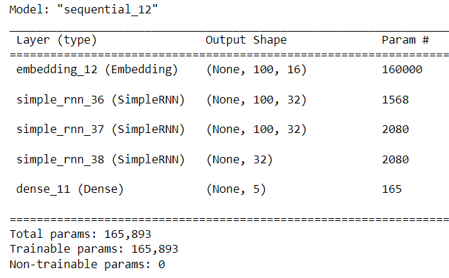

Figure 1.1: Model 1a (Baseline model) layers and structure

Model 1A consists of 1 Embedding layer, 1 dense layer wit the softmax activation function, and 3 SimpleRNN layers with 32 units each. The dense layer will remain unchanged throughout the building of the different sentiment analysis models. The first type of models that was experimented with are RNN network models. This is used as the baseline model that will be further scaled up.

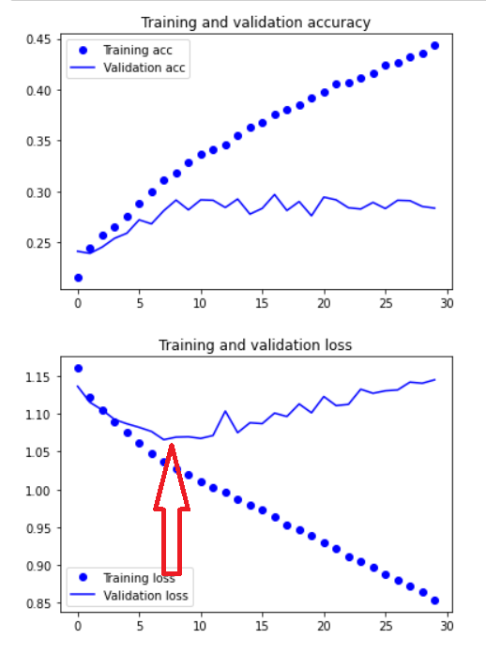

Figure 1.2:Model 1A Training & Validation Accuracy and Loss Score Graphs

Based on the training and validation accuracy and loss score graphs, model 1A overfits very early on, after about the 6th epoch, as seen from the validation loss starting to increase after about the 6th epoch, while the training loss continues to decrease. Model 1a’s train performance was about 44.34% for accuracy and 0.8540 loss, while its validation performance was about 28.37% for accuracy and 1.1448 for loss.

Despite overfitting very early on within the first few epochs, the model will continue to be scaled up as for the approach taken for building the sentiment analysis model would be to obtain a good training performance as the first concern that needs to be addressed is underfitting, thus the model will be scaled up until an optimal training performance is obtained. After which, regularization and dropout techniques are applied to the model to reduce overfitting and improve testing/validation accuracy. However, if tuning the model parameter causes a drastic increase in the validation accuracy with a slight increase or even decrease in training accuracy only, the tuned parameter that provided the much higher validation accuracy will be used instead. But, the main approach is to scale up the model until an optimal training performance is reached via the hyper tuning of the model parameters after which overfitting treatment is applied. This is because overfitting treatment techniques like regularization and dropout layers, the training performance will worsen, but with the benefit of the test performance becoming better. Thus, after getting an optimal training performance is the stage where the training performance is sacrificed for the sake of the validation/test performance. The first parameter explored is the dimension of the embedding layer. In model 1a, the dimension for the embedding layer was 16.

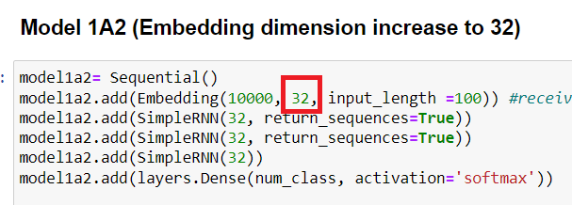

Figure 1.3: Model 1A2 Embedding layer increased to 32 from 16

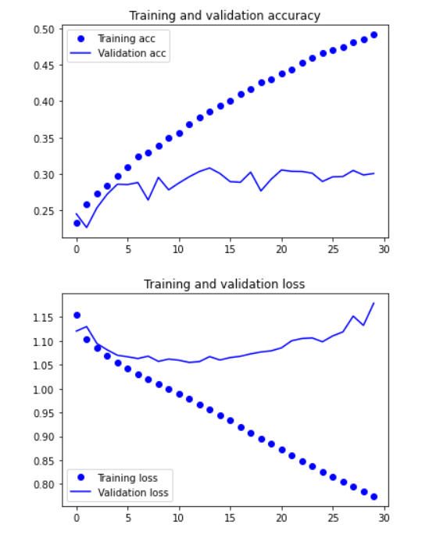

Figure 1.4: Model 1A2 Training and Loss Graphs

Based on the figure 1.4, model 1A2 overfits very early on as well, similar to model 1A, after about the 6th epoch, as seen from the validation loss starting to increase after about the 6th epoch, while the training loss continues to decrease. Model 1a2’s train performance was about 49.16% for accuracy and 0.7745 loss, while its validation performance was about 30.06% for accuracy and 1.1789 for loss. From this, the increasing of the embedding dimension has shown and increase in the overall performance of the model and the training accuracy. Thus, for the next model, the embedding dimension will continue to be increased.

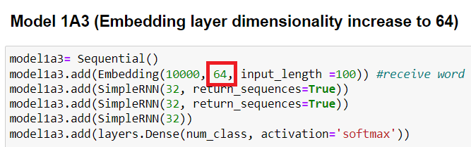

Figure 1.5: Model 1A3 embedding dimension increased to 64 from 32

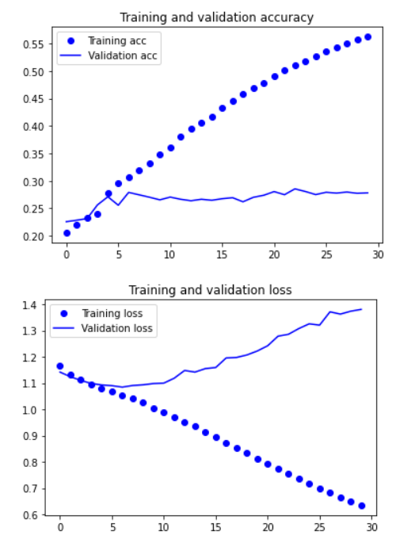

Figure 1.6: Model 1A3 Training and Loss Graphs

Based on the figure 1.6, model 1A3 overfits very early on as well, similar to model 1A and 1A2, after about the 6th epoch, as seen from the validation loss starting to increase after about the 6th epoch, while the training loss continues to decrease. Model 1a3’s train performance was about 56.26% for accuracy and 0.6344 loss, while its validation performance was about 27.81% for accuracy and 1.3805 for loss. From this, the increasing of the embedding dimension has shown and increase in training accuracy despite the slight decrease in testing accuracy. Because of the drastic increase in training accuracy compared to the smaller decrease in test accuracy, the embedding dimension will be further increased.

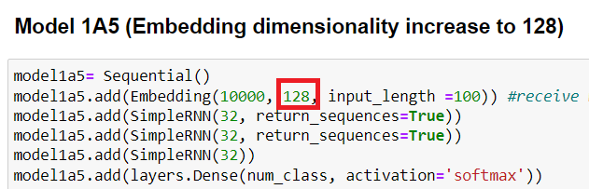

Figure 1.7: Model 1A5 embedding dimension increased to 128 from 64

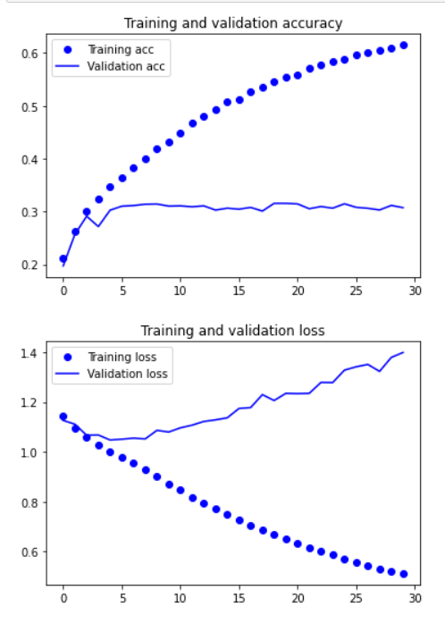

Figure 1.8: Model 1A5 Training and Validation Loss Graphs

Based on the figure 1.8, model 1A5 overfits very early on as well, similar to model 1A and the previous models, after about the 6th epoch, as seen from the validation loss starting to increase after about the 6th epoch, while the training loss continues to decrease. Model 1a5’s train performance was about 61.52% for accuracy and 0.5125 loss, while its validation performance was about 30.73% for accuracy and 1.3984 for loss. From this, the increasing of the embedding dimension has shown and increase in training accuracy with a slight increase in test accuracy from model 1A4. Hence, because of the overall increase in model performance, the dimension of the embedding layer would be further increased.

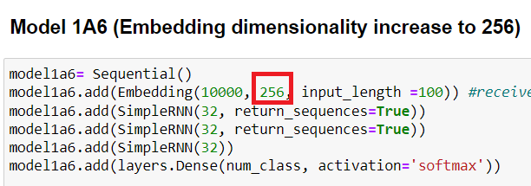

Figure 1.9: Model 1A6 Embedding Dimensionality increased to 256 from 128

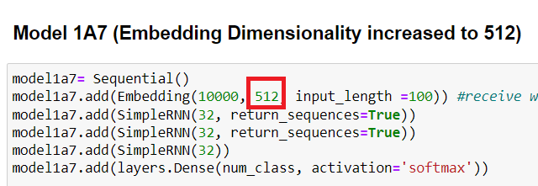

Figure 1.10: Model 1A7 Embedding Dimensionality increased to 512 from 256

When comparing model 1A6 and 1A7, they differ in terms of the embedding dimensionality used. Model 1A6 uses 256, while Model 1A7 use 512. However, when comparing their train and validation performances, Model 1A6’s train performance was about 64.43% for train accuracy and 0.4062 for loss,while its validation performance was about 31.08% for validation accuracy and 1.5058 for loss. On the other hand, model 1A7’s train performance was 67.90% for accuracy and 0.3299 for loss, while its validation performance was 27.44% for accuracy and 1.6917 for loss. Despite model 1A7 having a 3% increase in train accuracy over model 1A6, model 1A6’s validation performance is much better than model 1A7. Hence, because of model 1A6’s better validation performance over model 1A7’s, with model 1A6 only sacrificing abit of train accuracy, the embedding dimensionality will not be increased any further, and the embedding dimensionality of 128 will be used for the rest of the model testing phase.

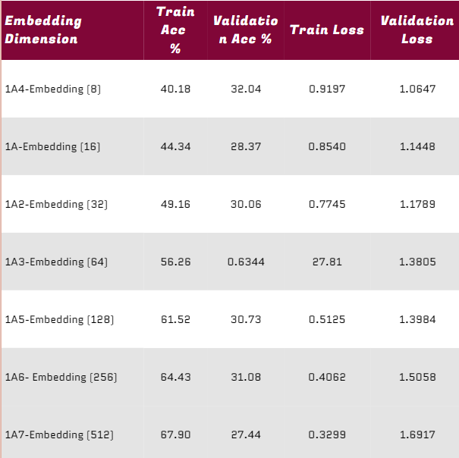

Figure 1.11: Table Summary of Models with different embedding dimensions

Figure 1.11 compiles the different models tested out by changing the dimensions of the embedding layer, to investigate its effect on the models’ performances and to find the optimal dimensionality for the embedding layer, which is 128.

After investigating the embedding dimensionality and its effect on the models’ performance, the steepness (number of layers) of the model is tested next. Some models can have a very deep network as they are tackling very complex problems, however, too complex of a model for a simple problem can lead to a decrease in model performance and metrics. When a neural network is very deep for a given problem, it tends to try and recreate the identity. This is because the first portion of the network has already found an effective set of weights that optimize the objective, and now the latter portion of the neural network is essentially adding noise. Thus the latter portion will attempt to create an identity function, which is terrible because it is trying to make an identity function from a nonlinear set of activations. On the other hand, if a model created is too shallow (too less layers), the problem of underfitting is introduced, this means that there are more features to be extracted and learned from and that there is more progress to be made when training. Bychanging the number of RNN layers and adjusting it according to the model metrics, the optimal steepness of the model is able to be determined such that it is both not underfitting and not too deep such that the extra layers are just noise to the model. This section of the report will highlight the interesting discoveries when experimenting with the layer count of our model.

To start off, the number of simpleRNN layer is increased to 5 from 3 in base model 1A.

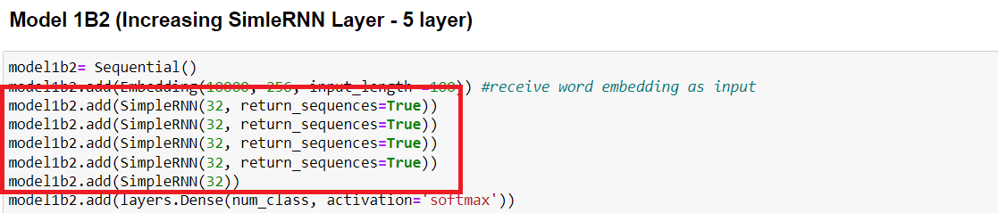

Figure 2.1: Model 1B2 - Increasing number of SimpleRNN layers to 5 from 3

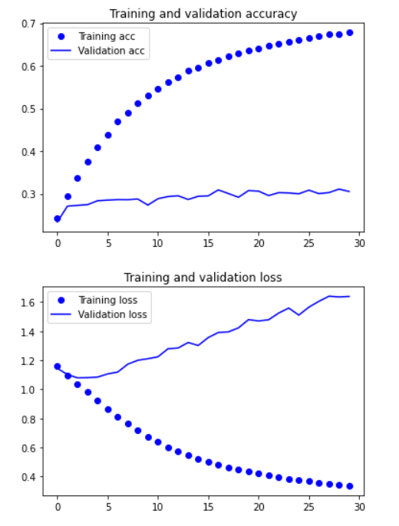

Figure 2.2: Model 1B2 Training and Validation Accuracy and Loss Graphs

Based on the figure 2.1, model 1B2 overfits very early on as well, similar to model 1A and the previous models, after about the 6th epoch, as seen from the validation loss starting to increase after about the 6th epoch, while the training loss continues to decrease. Model 1B2’s train performance was about 67.82% for accuracy and 0.3370 loss, while its validation performance was about 30.54% for accuracy and 1.6393 for loss. Compared to Model 1A6, there is a 3% increase in training accuracy, while only a 1% or less decrease in validation accuracy. Therefore, it can be concluded that there is an overall improvement in model performance when increasing the number of simpleRNN layers. This is further tested out on different models by increasing and decreasing the number of simpleRNN layers and its effect on the models’ performances.

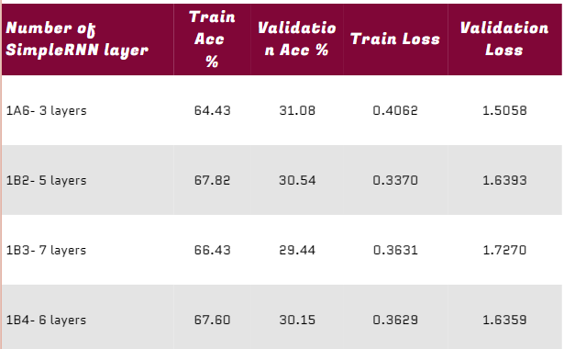

Figure 2.3: Table Summary of Models with different number of simpleRNN layers

Figure 2.3 compiles the model performances of the different models with different number of simpleRNN layers. Based on the table, when the number of layers was increased from 5 to 7, the overall model performance decreased, both the training and validation performance. Thus, model 1B4 is created to see whether increasing the number of simpleRNN layers to 6 is better, or 5 is the optimal number of simpleRNN layers to use. Based on the model performances for 1B2 and 1B4, model 1B2 performs slightly better than model 1B4 for both training and validation. This means that the optimal number of simpleRNN layers to use is 5.

After finding the optimal number of RNN layers, the different model structures are explored with different types of layers (GRU, LSTM) to investigate its effect on the models’ performances.

To start off, the structure of model 1B2 is used, with the addition of 1 LSTM layer.

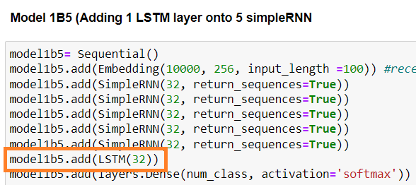

Figure 3.1: Model 1B5, 1 LSTM layer added to Model 1B2

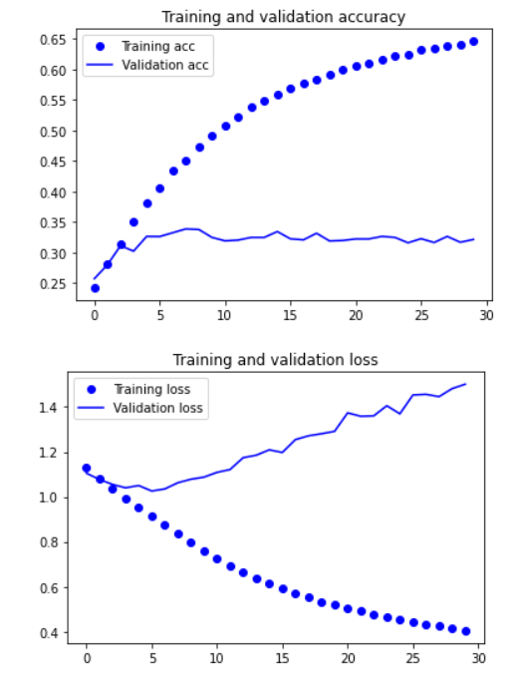

Figure 3.2: Model 1B5 Training and Loss Graphs

Based on the figure 3.2, model 1B5 overfits very early on as well, similar to model 1A and the previous models, after about the 6th epoch, as seen from the validation loss starting to increase after about the 6th epoch, while the training loss continues to decrease. With the similar performances explored so far when it comes to overfitting, this shows that the overfitting would have to be addressed later on, after achieving the optimal train performance. Model 1B5’s train performance was about 64.62% for accuracy and 0.4045 loss, while its validation performance was about 32.15% for accuracy and 15013 for loss. Compared to Model 1B2, there is a 3% decrease in training accuracy. Therefore, it can be concluded that when an additional LSTM layer is added, the training performance drops, which means its not optimal for the sentiment analysis model.. This is further tested out on different models by experimenting different combinations of different types of layers (GRU, LSTM, SimpleRNN) and how they affect the overall performance of the model.

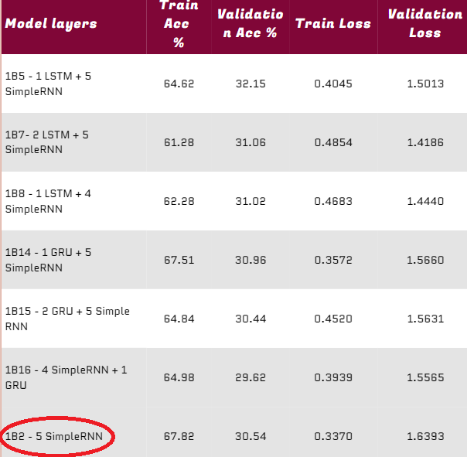

Figure 2.3: Table Summary of Models with different number of simpleRNN layers

Figure 2.3 compiles the different models with different layer combinations by adding/substituting other layers like the GRU or LSTM layer. Based on figure 2.3, when compared to model 1B2, none of the other models achieved a higher train accuracy. Additionally, these models also achieved validation accuracies much more than the validation accuracy of model 1B2. As for the approach taken, if the model has a lower train accuracy but a much higher validation accuracy, then that model would be chosen as sacrificing abit of the accuracy for a much higher validation accuracy is better in terms of building the model. Therefore, it can be concluded the model 1B2’s current model layers and structure of 5 simpleRNN layers is the most optimal. Moving on, the different optimizers will be tested and its effect on model 1B2’s model performance.

Different optimization algorithms or optimizers widely affect the accuracy of the deep learning model. They as well as affect the speed training of the model. An optimizer is a function or an algorithm that modifies the attributes of the neural network, such as weights and learning rates. Thus, it helps in reducing the overall loss and improving the accuracy. The problem of choosing the right weights for the model is a daunting task, as a deep learning model generally consists of millions of parameters. It raises the need to choose a suitable optimization algorithm. These are the types of optimizers tested:

Stochastic Gradient Descent: An optimization algorithm often used in machine learning applications to find the model parameters that correspond to the best fit between predicted and actual outputs. It is is an iterative method for optimizing an [objective function](https://en.wikipedia.org/wiki/Objective_function) with suitable [smoothness](https://en.wikipedia.org/wiki/Smoothness) properties (e.g. differentiable or subdifferentiable). It can be regarded as a stochastic approximation of gradient descent optimization, since it replaces the actual gradient (calculated from the entire [data set](https://en.wikipedia.org/wiki/Data_set)) by an estimate thereof (calculated from a randomly selected subset of the data). Especially in high-dimensional optimization problems this reduces the very high computational burden, achieving faster iterations in exchange for a lower convergence rate.

Adams: A replacement optimization algorithm for stochastic gradient descent for training deep learning models that combines the best properties of the AdaGrad and RMSProp algorithms to provide an optimization algorithm that can handle sparse gradients on noisy problems.

Adadelta: A stochastic gradient descent method that is based on adaptive learning rate per dimension to address two drawbacks: The continual decay of learning rates throughout training and the need for a manually selected global learning rate. It is a more robust extension of Adagrad that adapts learning rates based on a moving window of gradient updates, instead of accumulating all past gradients. This way, Adadelta continues learning even when many updates have been done. Compared to Adagrad, in the original version of Adadelta you don't have to set an initial learning rate.

Adagrad: An optimizer with parameter-specific learning rates, which are adapted relative to how frequently a parameter gets updated during training. The more updates a parameter receives, the smaller the updates.

Adamax: A variant of Adam based on the infinity norm, and a first-order gradient-based optimization method. Due to its capability of adjusting the learning rate based on data characteristics, it is suited to learn time-variant process, e.g., speech data with dynamically changed noise conditions. It is an extension to the Adam version of gradient descent that generalizes the approach to the infinite norm (max) and may result in a more effective optimization on some problems.

Nadam: Short for Nesterov-accelerated Adaptive Moment Estimation, which is an optimization algorithm used for training deep neural networks. It is a combination of the popular Adam optimization algorithm and Nesterov's Accelerated Gradient (NAG) method.Like Adam, NADAM computes adaptive learning rates for each parameter based on the historical gradient information. However, it also incorporates NAG's technique of looking ahead by using the gradient information at the point where the next update step is taken, rather than only using the gradient information at the current position. This allows NADAM to have a faster convergence rate and better stability compared to other optimization algorithms. NADAM is also less sensitive to the choice of hyperparameters compared to Adam and generally requires fewer training iterations to reach a good solution. It is a good choice for training deep neural networks with large amounts of data and complex architectures.

Ftrl: An optimization algorithm used for training machine learning models, particularly linear models. It is a variation of the popular stochastic gradient descent (SGD) optimization algorithm, but with a different approach to updating the model weights. In FTRL, the model weights are updated based on a combination of the gradient of the loss function with respect to the weights and the magnitude of the weights themselves. This allows FTRL to achieve a more efficient and scalable optimization process, especially when the number of features is large. FTRL also has a regularization term built into the optimization process, which helps to prevent overfitting. The regularization term is controlled by a hyperparameter, which can be adjusted to balance the trade-off between model accuracy and overfitting.

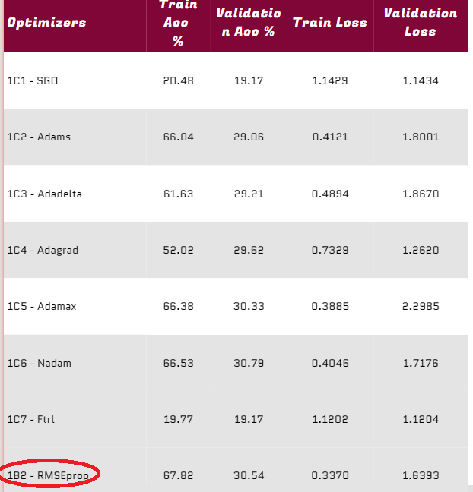

Figure 3.1: Table Summary of Models with different optimizers

Figure 3.1 compiles the different model performances of the different models utlizing different optimizers and how they affect the performances of models.Based on figure 3.1, there are some optimizers that do not go well with the sentiment analysis model. This could be because the optimizer algorithm does not fit the problem or the data.The models wiith unusually low performances are model 1C1, which uses the SGD optimizer and model 1C7, which uses the Ftrl optimizer.Therefore, out of all the optimizers tested, RMSEprop optimizer with learning rate of 1e-4 provided the best performance, which is model 1B2.

After finding out the best optimizer to use, the number of units for each layer will now be tested and how the affect the model’s performance. For this, the number of units for each simpleRNN layer will be gradually increased until it shows signs of deterioration in performance. By increasing the number of units in the simpleRNN layers, it can help to improve the capacity of a recurrent neural network (RNN) to model more complex relationships between the input and output sequences. Each unit in a SimpleRNN layer represents a single artificial neuron, and the number of units determines the size of the hidden state vector that the layer can maintain. A larger hidden state vector means that the layer can potentially capture more information about the history of the input sequence. This can be particularly useful in cases where the input sequence is long or contains complex dependencies that need to be modeled. However, increasing the number of units also increases the number of parameters in the model, which can lead to overfitting if the amount of training data is limited. To prevent overfitting, it may be necessary to use regularization techniques, such as dropout or early stopping, when increasing the number of units in a SimpleRNN layer. In general, finding the optimal number of units for a SimpleRNN layer is a trade-off between capturing enough information about the input sequence to make accurate predictions and avoiding overfitting by keeping the number of parameters in the model under control. A good approach is to start with a small number of units and gradually increase it while monitoring the performance on a validation set, until a satisfactory balance is reached. Additionally, having too much parameters can cause the model performance to deteriorate.

To start off, the first simpleRNN layer has increased units from 32 to 64

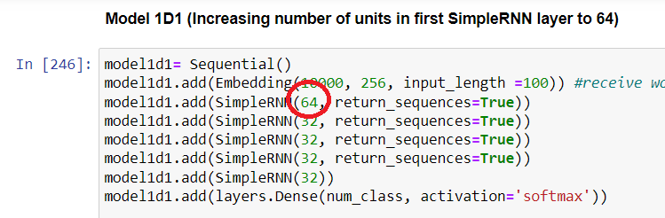

Figure 4.1: Model 1D1 (First SimpleRNN layer units increased to 64 from 32)

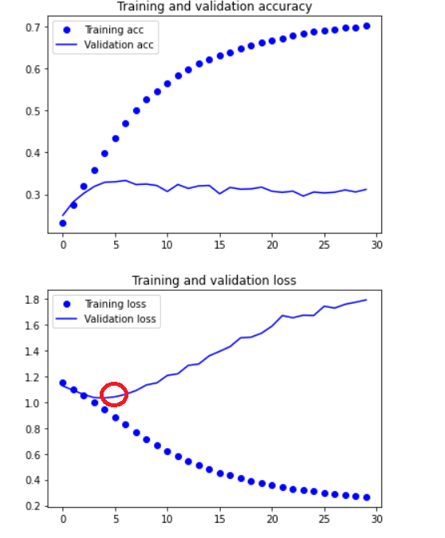

Figure 4.2: Model 1D1 training and validation graphs

Based on figure 4.2, model 1D1 starts to overfit very early, after about the 5th epoch. This is most likely because the units of the layer increase, thus the model starts to over learn the input features of the data. Model 1D1 achieved a training performance of 70.14% for training accuracy, 0.2665 for training loss, and a validation performance of 31.21% for validation accuracy, 1.7921 for validation loss. This is an increase in training accuracy over model 1B2, with barely any change in the validation performance.

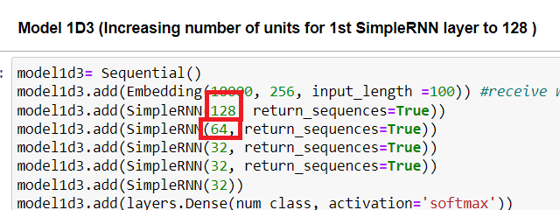

Figure 4.3: Model 1D3 (First simpleRNN layer units increased to 128 from 64, second simpleRNN layer units increases to 64 from 32)

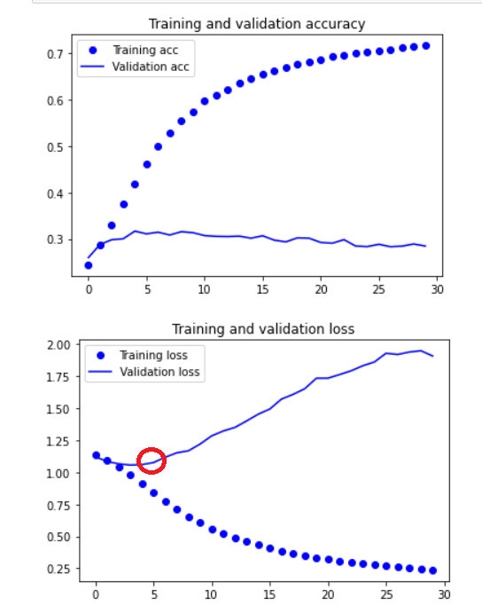

Figure 4.4: Model 1D3 Training and Loss Graphs

Based on figure 4.4, model 1D3 starts to overfit very early on as well, after about the 5th epoch also. However, the model performance for model 1D3 was abit better as it achieved a training performance of 71.63% for training accuracy, 0.2367 for training loss and 28.46% for test accuracy, 1.9090 for training loss. With this increase in training performance, the layer units are further increased.

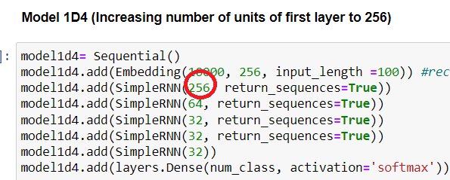

Figure 4.5: Model 1D4 (Increase units of first simpleRNN layer to 256 from 128)

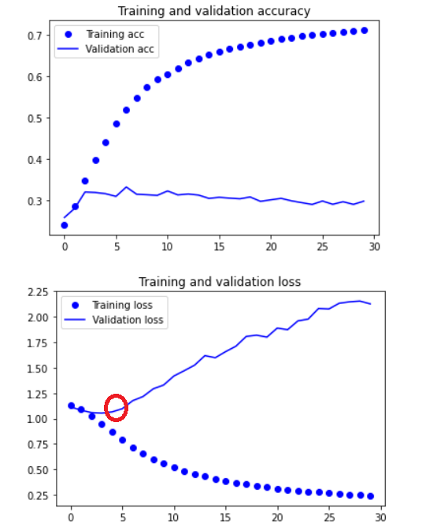

Figure 4.6: Model 1D4 Training and Loss Graphs

Based on figure 4.6, the training and loss graphs show that after increasing the number of units in the first simpleRNN layer to 256 from 128, the model starts to overfit abit earlier after about the 4th epoch. This could be due to the even larger increase in complexity of the model, causing it to overfit more. Additionally, model 1D4 achieved a training performance of 71.19% for training accuracy, 0.2425 for training loss, and a validation performance of 29.75% for validation accuracy, 2.1282 for validation loss. With this decrease in training accuracy from model 1D3 and increase in overfitting, the number of units for each simpleRNN will follow the structure of model 1D3.

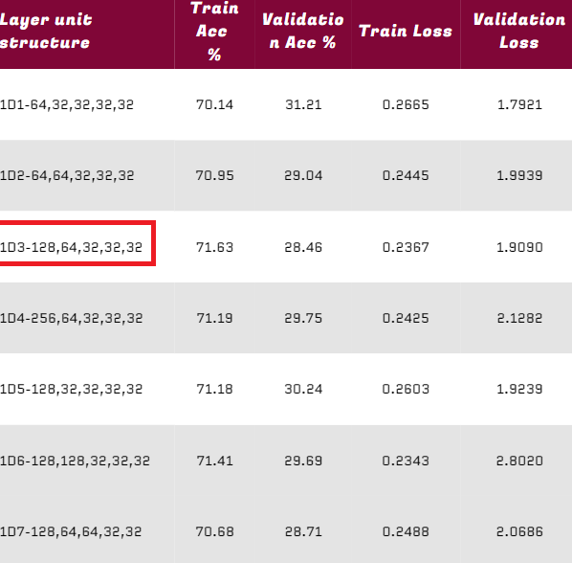

Figure 4.7: Table summary of different model with different layer unit structures

Based on figure 4.7, the model that provided the best training performance without sacrificing too much validation performance is model 1D3, with a training accuracy of 71.63%, a training loss of 0.2367, a validation accuracy of 28.46%, and a validation loss of 1.9090. Therefore, the overfitting treatment testing will be done on model 1D3.

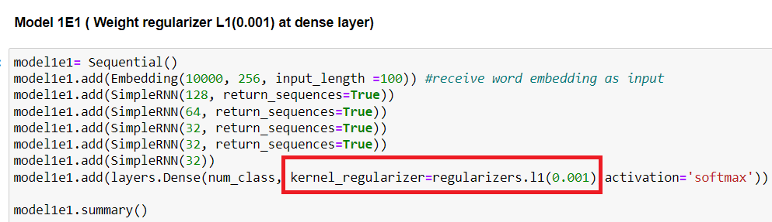

Figure 5.1: Model 1E1 (Weight regularizer 0.001 on dense layer)

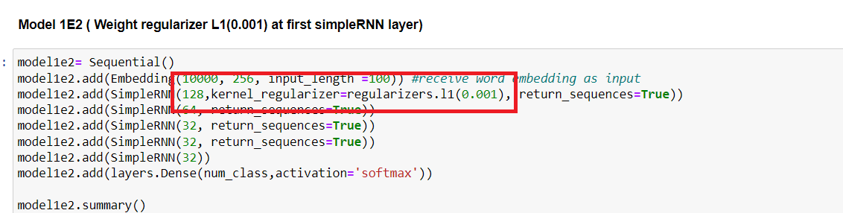

Figure 5.2: Model 1E2 (Weight regularizer 0.001 on first simpleRNN layer)

The weight regularizer are placed on the dense and first simpleRNN layer on different models to compare whether their position affects the overfitting of the model.

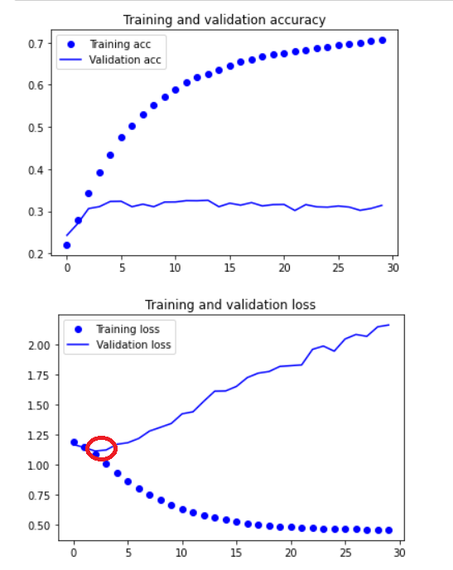

Figure 5.3: Model 1E1 Training and Loss Graphs

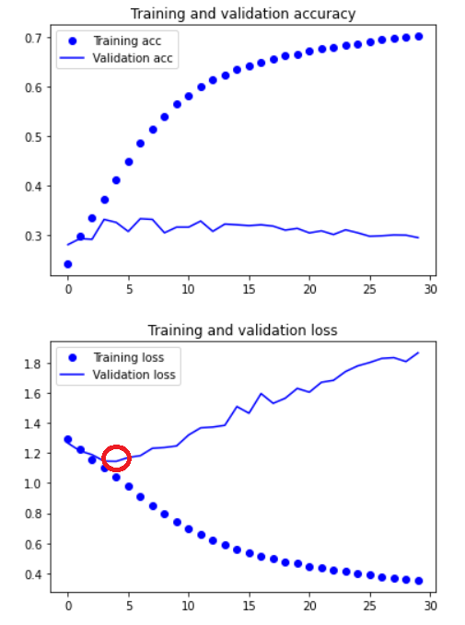

Figure 5.4: Model 1E2 Training and Loss Graphs

When looking at the training and loss graphs for model 1E1 and 1E2, their effect on the overfitting of the model seems to be minimal if not worst. This can be seen from the overfitting of the model starting after about the 3rd or 4th epoch. For model 1D3, the overfitting also starts after about the 4th epoch. Hence, it is concluded that the L1 weight regularizer is not a good to treat overfitting for model 1D3. With such minute differences to the overfitting of model 1D3, the testing of the L2 weight regularizer will be placed in the first simpleRNN layer as when the L1 weight regularizer was placed in the first simpleRNN layer as compared to the dense layer, it had a 7% increase in training accuracy as compared to placing the weight regularizer in the dense layer.

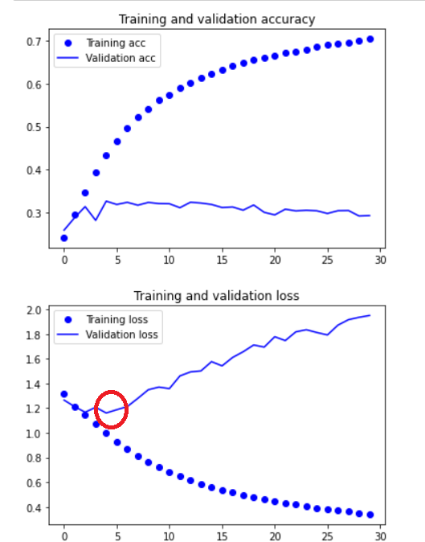

Figure 5.5: Model 1E3 (L2 Weight regularizer) Training and Loss Graphs

Based on figure 5.5, the L2 weight regularizer barely has any effect on the overfitting in model 1D3. This menas that the L2 is similar to the L1 weight regularizer, in the sense that they both have little to no effect when dealing with the overfitting in the model.

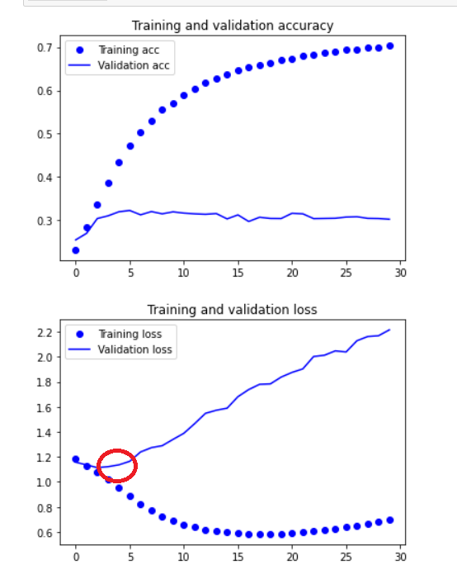

Figure 5.6: Model 1E4 (L1+L2 Weight Regularizer) Training and Loss Graphs

Based on figure 5.6, even when using both the L1 and L2 weight regularizer, the overfitting in the model seems to have not changed at all. Hence, the weight regularizer will not be used in the model to deal with overfitting.

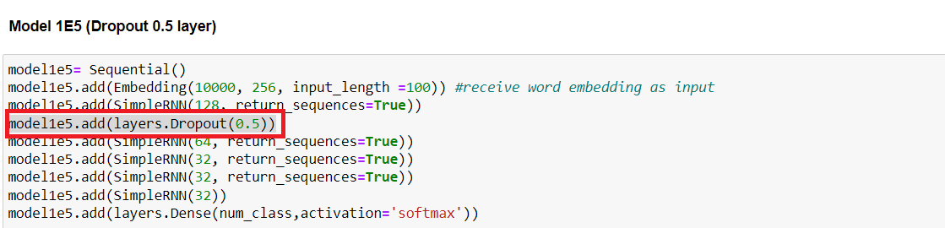

Figure 5.7: Model 1E5(Dropout 0.5 layer added)

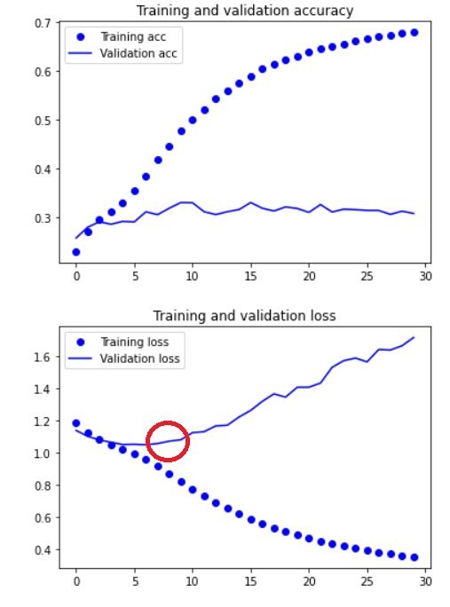

Figure 5.8: Model 1E5 (Dropout 0.5) Training and Loss Graphs

Based on figure 5.8, model 1E5 overfits slightly later than the previous 1E models. From the graphs, model 1E5 overfits after about the 6th or 7th epoch which is a slight improvement over the other overfitting treatment techniques. Hence, the dropout value will be configured to see if a better result could be achieved.

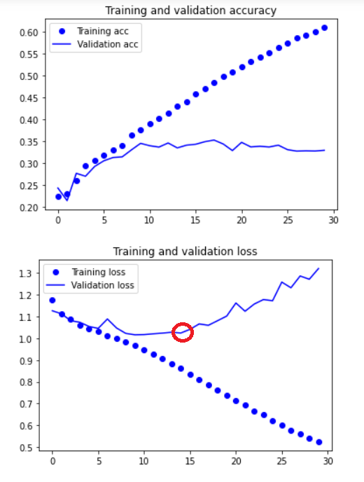

Figure 5.9: Model 1E7 (Dropout 0.25 layer) Train and Loss Graphs

For model 1E7, the dropout layer with value 0.25 is tested. Based on figure 5.9, it can be seen that the overfitting starts later than average. Based on the graphs, the overfitting for model 1E7 starts after about the 14th epoch. This shows that the dropout 0.25 layer has a much better effect on the overfitting of model in this case. However, when looking at the validation accuracy, it only achieved a validation accuracy of about 30%, which is the average of the past few models. Hence, despite the validation loss starting to increase at a later epoch compared to other models, the validation accuracy still remains relatively stagnant.

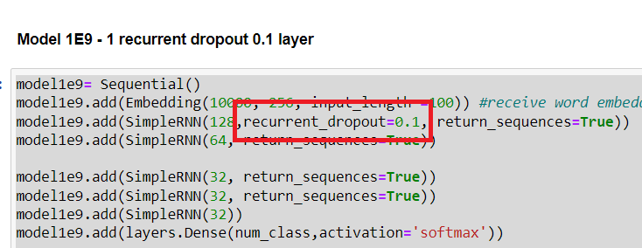

Figure 5.10: Model 1E9 (recurrent dropout 0.1)

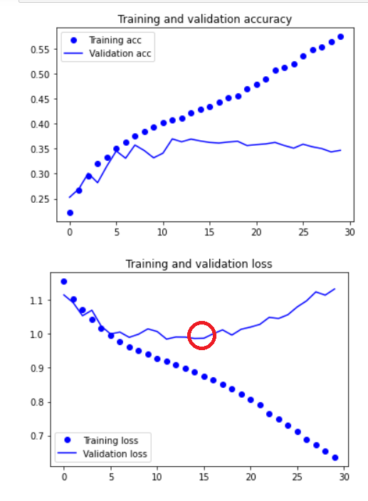

Figure 5.11: Model 1E9 (recurrent dropout 0.1) Training and Validation Graphs

Based on figure 5.11, it can be seen that the recurrent dropout 0.1 layer has a similar effect on the overfitting of the model as the dropout 0.25, with the model starting to overfit aftr about the 14th epoch. However, when looking at the validation accuracy, model 1E9 has achieved a validation accuracy of about 34.67%, which is a marginal difference from model 1E7.

After investigating and exploring the different overfitting techniques and their effect on the model for this given data, different models with different combinations of overfitting techniques will be explored. For example, combing a dropout 0.25 layer with a recurrent dropout of 0.1.

After exploring the different combinations of overfitting techniques, the models which provided better results in terms of minimal overfitting are model 1E13 and 1E15.

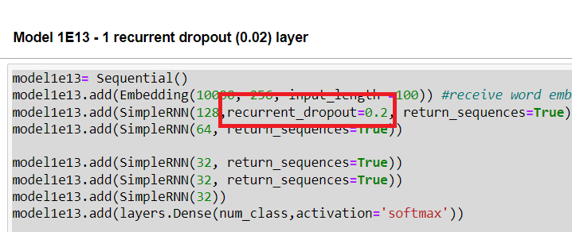

Model 5.12: Model 1E13 (recurrent dropout 0.02)

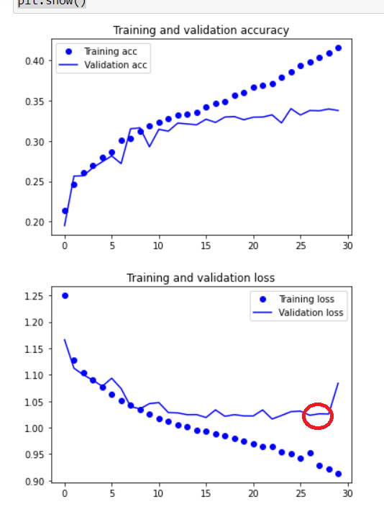

Figure 5.13: Model 1E13 (recurrent dropout 0.2)

Based on figure 5.13, the overfitting for model 1E13 starts much later after about the 26th epoch. This is much better compared to the other overfitting methods. Additionally, when looking at the validation accuracy achieved of 33.77%, the recurrent dropout 0.2 is concluded to have a positive effect on the overfitting on the model. However, it comes at the expense of the training accuracy as it only reached 41.54%. This is because its due to the recurrent dropout is randomly dropping out (i.e., setting to zero) a certain percentage of activations in the hidden state at each timestep, during both the forward and backward passes of the training process. This effectively prevents the model from relying too heavily on any single feature or activation, forcing it to consider a wider range of information when making predictions.

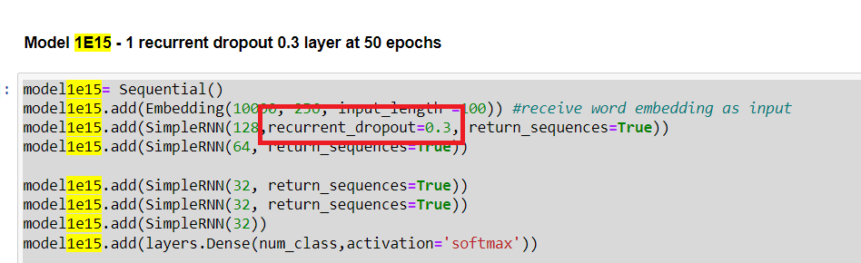

Figure 5.14: Model 1E15 (recurrent dropout 0.3)

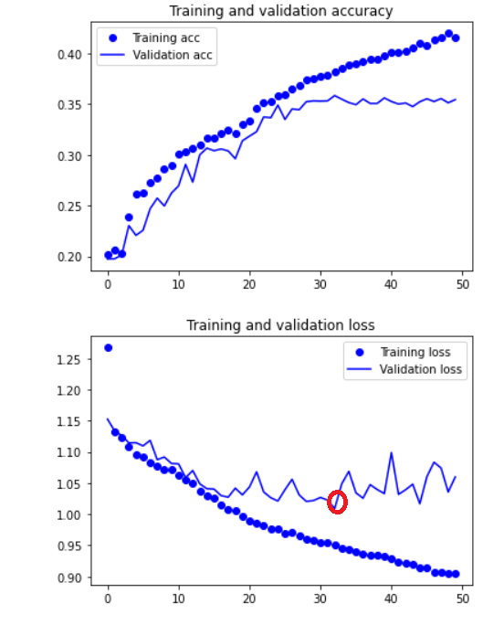

Figure 5.15: Model 1E15 (recurrent dropout 0.3)

Based on figure 5.15, the overfitting for model 1E15 starts much later after about the 30th epoch. This is much better compared to the other overfitting methods. Additionally, when looking at the validation accuracy achieved of 35.46%, the recurrent dropout 03 is concluded to have a positive effect on the overfitting on the model. However, it comes at the expense of the training accuracy as it only reached 41.62%. This is because its due to the recurrent dropout is randomly dropping out (i.e., setting to zero) a certain percentage of activations in the hidden state at each timestep, during both the forward and backward passes of the training process. This effectively prevents the model from relying too heavily on any single feature or activation, forcing it to consider a wider range of information when making predictions.

After exploring the different overfitting methods and combinations, the batch nomalization layer is then tested on model 1D3 to see how it affects the model.The batch nomalization layer is a technique used to normalize the activations of a neural network, with the goal of speeding up the training process and improving the network's ability to generalize to unseen data. In the context of sentiment analysis, batch normalization can be applied to the activations of the hidden layers in the network. The goal is to ensure that the activations have a mean close to zero and a standard deviation close to one, which can help to stabilize the learning process and reduce the impact of outliers or extreme values. Batch normalization works by normalizing the activations within a mini-batch of data during the forward pass of the network, rather than normalizing all activations over the entire dataset. This helps to reduce the internal covariate shift, which refers to the changes in the distribution of activations throughout the network as it trains. By reducing the internal covariate shift, batch normalization can make the training process more stable and reduce the risk of overfitting.

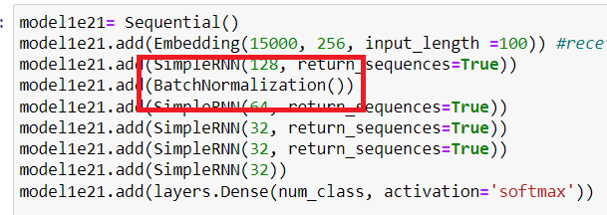

Figure 6.1: Model 1E21 (model 1D3+Batch nomalization layer)

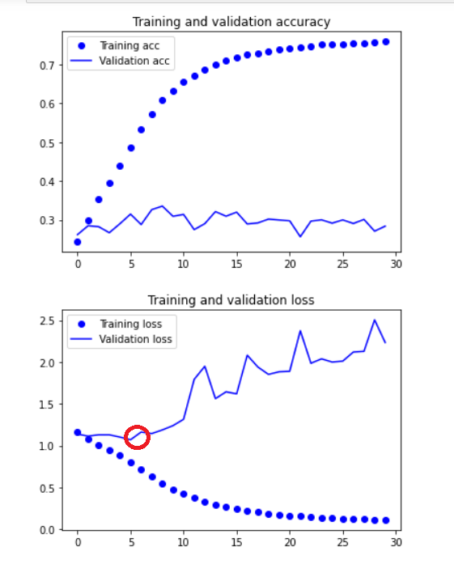

Figure 6.2: Model 1E21 (Batch Nomalization layer) Training and Validation Graphs

Based on figure 6.2, model 1E21 starts to fit very early on with the batch nomlization layer. However, when looking at the training performance, its accuracy increased by about 5% from Model 1D3, achieving a train accuracy of 75.94% and a train loss of 0.1133. However, on the other hand, it only achieved a validation accuracy of only 28.37% and a validation loss of 2.3344, which indicates major overfitting. Thus, the overfitting techniques experimented and explored in the previous section will be applied onto model 1E21, in order to minimise its overfitting.

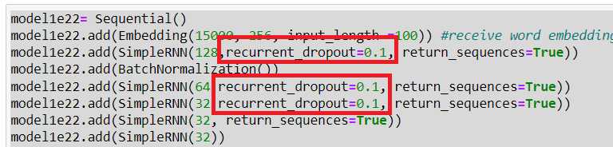

Figure 6.3: Model 1E22 (3 recurrent dropout 0.1 + BatchNomilization)

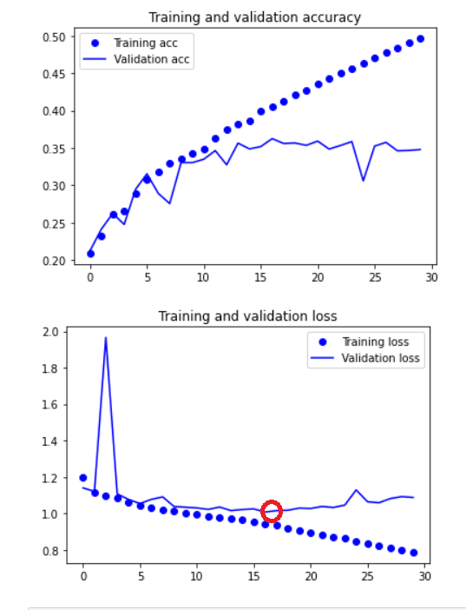

Figure 6.4: Model 1E22 Training and Validation Graphs

After much exploration of the overfitting techniques on model 1E21, the only model that provided lesser than average overfitting was Model 1E22. Based on the graph, the model starts to overfit after about the 16th epoch, which is an improvement from model 1E21. However, when looking at the validation accuracy, it only achieved a validation accuracy of about 34.79%, which is lower compared to model 1E15 (Model 1D3+ recurrent dropout 0.3)

Further exploration with LSTM layers and CNN networks, with the optimal optimizer and embedding dimensionality used as it has been explored in the previous part already,were also conducted to see if a better model could be achieved. However for the CNN networks, most of them gave increasing losses and very low accuracies.

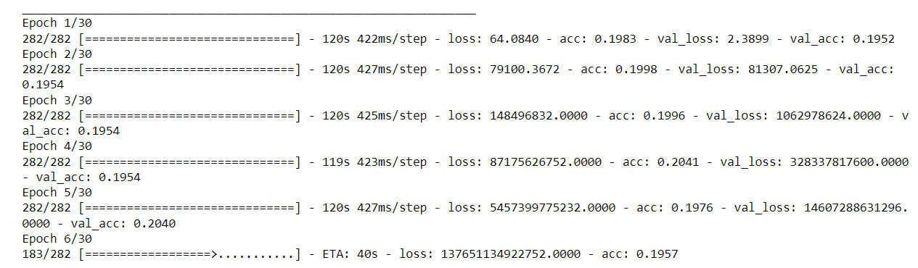

Figure 7.1: Exponential increase in loss for CNN network

On the other hand, LSTM layers provided very early overfitting models despite having some models with a minor increase in validation accuracy over model 1E15, which has the highest validation accuracy out of all the simpleRNN models.

After using the different models with a validation accuracy of above 32% on the testing data, the best model that I have chosen is model 1E8. Despite it having a lower validation accuracy of 34.77% than some of the models, it achieved a relatively high accuracy of about 35.33% testing accuracy. During the training phase, it also achieved a training accuracy of about 53.56%

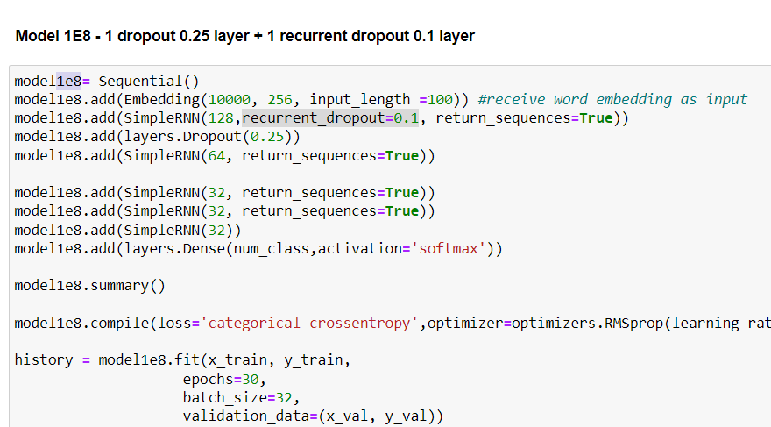

Figure 8.1: Best model chosen - Model 1E8

Model 1E8 achieved a good balance between the train, validation, and testing accuracy.

Additionally, when testing model 1E8 on another dataset, specifically Ethan’s Netflix reviews, it achieved a validation accuracy of 43.447%, which is a significant improvement compared to using the Spotify reviews dataset

## 3.4. Ayrton

In a multi-class classification problem, the loss function used will be ‘categorical_crossentropy’. Since there are 5 review rating categories to predict and categorize, there are 5 possible outputs, hence the last dense layer, which is the output layer, should have 5 nodes. Hence the SoftMax activation function is used.

In Recurrent Neural Networks (RNN), there are several algorithms that can be used, including SimpleRNN, LSTM and GRU. For this assignment, the chosen algorithm to work with is GRU.

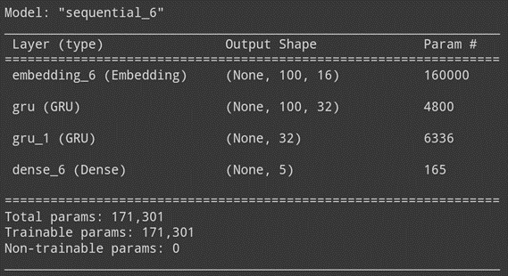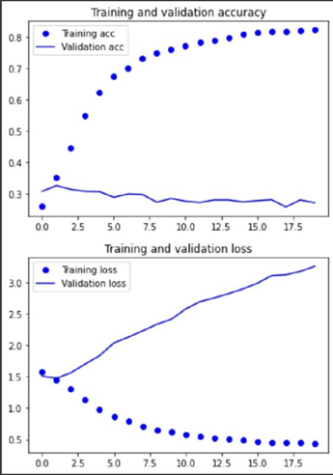

Fig. 1a: model4b summary Fig. 1a: model4b performance

Fig. 1a shows the GRU model built, model4. Model4 consists of 2 GRU layers with 32 nodes each. This model achieved a training and validation accuracy of 84.99% and 27.20% respectively. Suggesting that the model is very overfitted, as seen in Fig. 1b. Overfitting starts almost immediately, after the first epoch.

After this, the number of layers added will be experimented on. Below are models with 3, 4, 5, 6 GRU layers respectively. After training and comparison, it is seen that using 4 GRU layers give the best results as it gives the best overall model performance based on their training and validation accuracies, and the amount of overfitting. Having 4 GRU layers gives us a training and validation accuracies of 83.5% and 29.6% respectively, and training and validation losses of about 0.43 and 2.81 respectively. The model built with 4 GRU layers is as shown in Fig. 2a and 2b below.

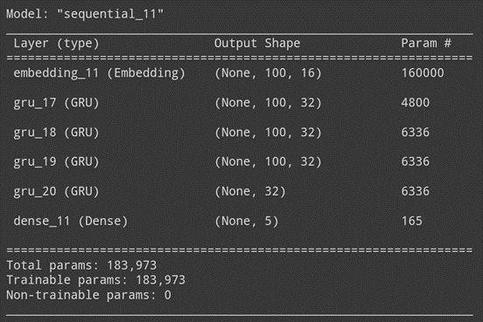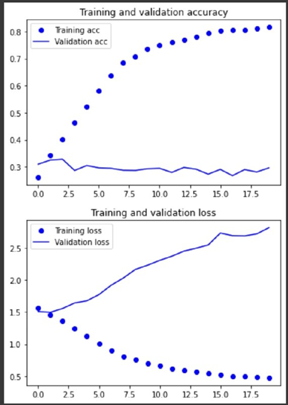

Fig. 2a: model4b summary Fig. 2b: model4b performance

Then the number of nodes used for each layer are experimented on. It is found that inputting 16 nodes for the embedding layer, 32, 64, 128 and 128 nodes for each respective GRU layer as shown in Fig. 3a, increases the model performance from the previous model 4e. model4e has 16 nodes for the input layer, followed by 32, 32, 64 and 128 layers for the following GRU layers, as shown in Fig. 3a. From model4e to model4f, the model’s validation accuracy improved from 26.48% to 29.2%, suggesting that increasing the right number of nodes can give a better model performance.

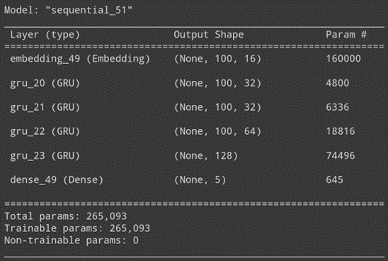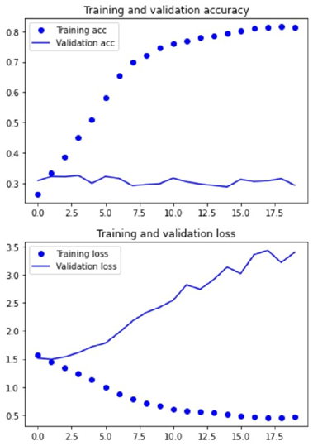

Fig. 3a: model4e summary Fig. 3b: model4e performance

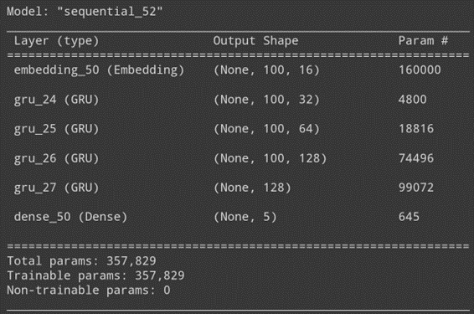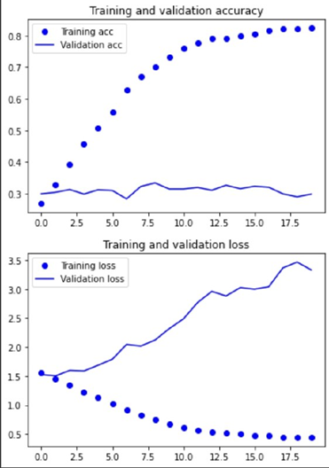

Fig. 4a: model4f summary Fig. 4b: model4f performance

From model4f to model4g, optimizers are experimented on to see its effects on the model performance. Comparing the optimizer ‘Adam’ to ‘rmsprop’, rmsprop gives a better model performance as it gives a 3% higher testing accuracy of 32.72% and lower training accuracy of 73.16%, hence reducing overfitting as well, making rmsprop the more appropriate optimizer to use based on its model performance.

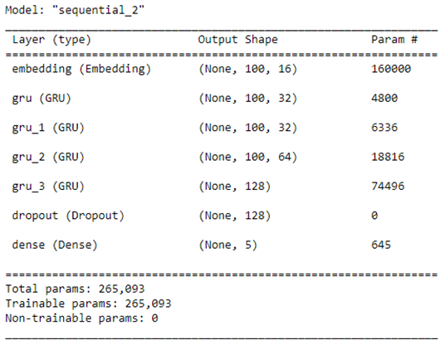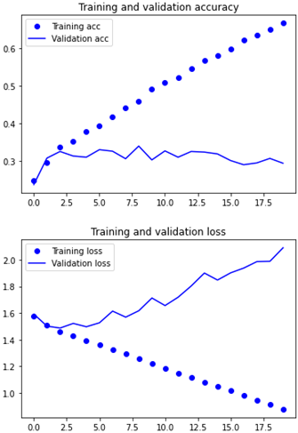

Fig. 5a: model4hi summary Fig. 5b: model4hi performance

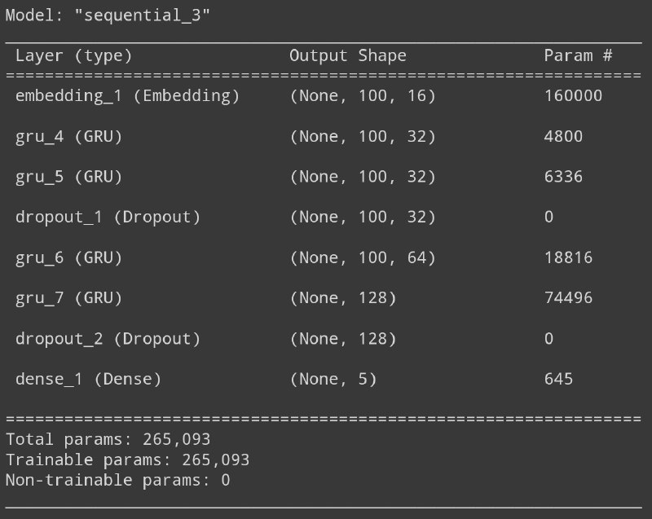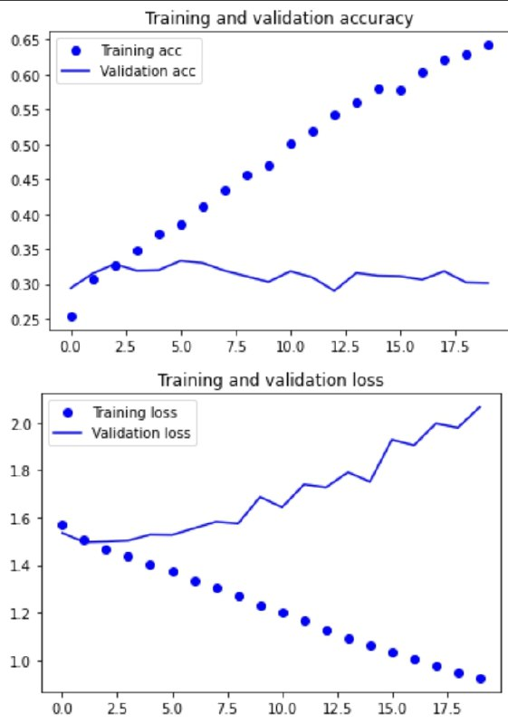

Fig. 6a: model4hii summary Fig. 6b: model4hii performance

Model4hi is as shown in Fig. 5a above. It consists of 4 GRU layers and a 0.5 dropout layer right before the last dense layer. From model 4g, a 0.5 dropout layer has been added before the last dense layer. This is because the ‘4h’ models are used to experiment the effects of dropouts on the Recurrent Neural Network (RNN). Hence, the addition of a dropout from model 4g. model4hi achieved a training and validation accuracy of 70.47% and 29.44%, which is a higher training accuracy than the 59% training accuracy achieved by model4g.

Looking at Fig. 6a above, another dropout layer is added to the model. It is observed that the model is still overfitted, with overfitting starting at about the second epoch. Adding an additional dropout layer in model4hii also improved the validation accuracy by 1%, giving it a training and validation accuracy of 67.77% and 30.16% respectively.

Since the model is still overfitted, more overfitting prevention methods can be implemented, such as L1 regularization, which is done in model4j as shown in Fig. 7a below. Adding regularization caused the training and validation accuracy to drop to 59.28% and 30% respectively.

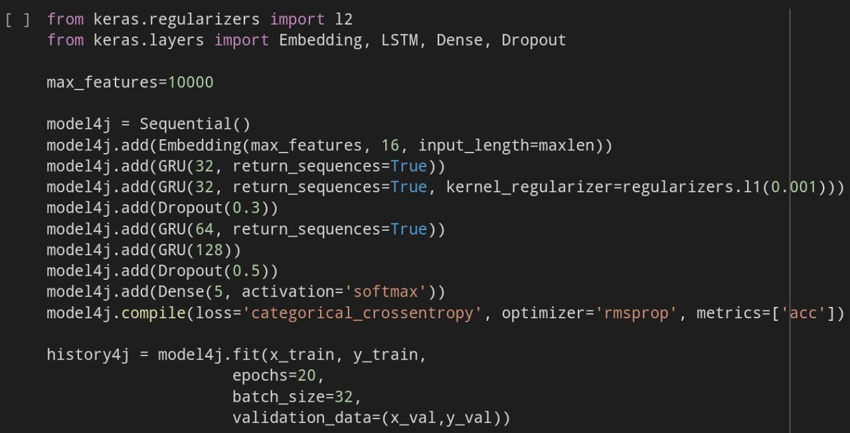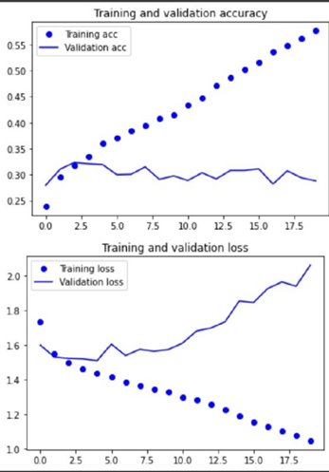

Fig. 7a: model4j summary Fig. 7b: model4j performance

Since model4hii has the highest testing accuracy of about 34% among all the models, this model will be chosen as the best model. It achieved a training and validation accuracy of 67.77% and 34.77% respectively.

## 3.5. Ethan

To start with the building of models, we first need to create a base model where we can judge our future model improvements based on. Since this is a classification problem with 5 classes, the final layer for all models should be a dense layer with softmax activation and 5 neurons.

The softmax function with 5 neurons transforms the output of the dense layer into a probability distribution over the 5 possible classes. The function outputs the probability of each class, with the highest probability corresponding to the predicted class.

The final layer is responsible for making the final prediction. The input to this layer is the output of the hidden layers, which has been processed and summarized to represent the relevant features for the prediction task. The softmax activation function maps these features to a set of probabilities, one for each class. The class with the highest probability is selected as the final prediction. The use of the softmax activation function in the final layer ensures that the output of the model is a valid probability distribution, with all the probabilities summing to 1. This allows the model to make a clear and well-calibrated prediction, while also taking into account the relative uncertainty of the prediction.

step 1 : After creating the base model, I will create other models and tune parameters. Things to consider are , learning rates, optimizers,optimizer parameters,epochs,batch sizes.

step 2:, I can experiment with regularization techniques such as dropout and l2 reg etc.

Once I have tested all these, I can also test out different types of neural networks such as rnn or cnn and repeat step 1 and 2 again

And finally, when I’m finished with all the testing, I can move on to ensemble learning where i combine a few of my best models into one model and hope it helps with with accuracy

**batch size**

model = Sequential()

model.add(Embedding(max_words ,16,input_length =maxlen))

model.add(LSTM(32,return_sequences=True))

model.add(LSTM(32))

model.add(Dense(5,activation='softmax'))

model.compile(loss='categorical_crossentropy',optimizer='rmsprop',metrics=['acc'])

history = model.fit(x_train,y_train,epochs =30,batch_size=32,validation_data=(x_val,y_val))

we started off with a batch size of 32

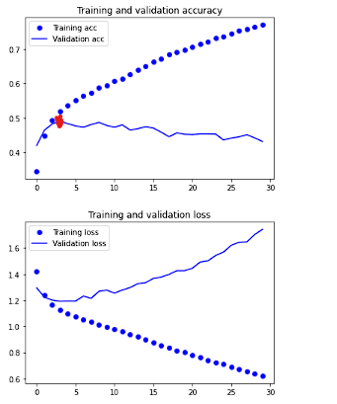

as we can see overvitting occurred around epoch 4 when the validation accuracy starts to decrease.

next we fit the model with batch size of 128

model = Sequential()

model.add(Embedding(max_words ,16,input_length =maxlen))

model.add(LSTM(32,return_sequences=True))

model.add(LSTM(32))

model.add(Dense(5,activation='softmax'))

model.compile(loss='categorical_crossentropy',optimizer='rmsprop',metrics=['acc'])

history = model.fit(x_train,y_train,epochs =30,batch_size=128,validation_data=(x_val,y_val))

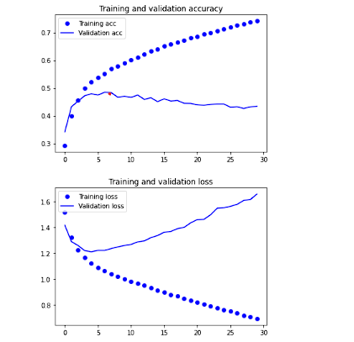

as we can see overfitting occurred at around epoch 7 where the accuracy started to decrease. This shows us that increasing batch sizes helps to delay overfitting slightly, hence we kept the batch size 128

**filter number**

model = Sequential()

model.add(Embedding(max_words,16,input_length =maxlen))

model.add(LSTM(16,return_sequences=True))

model.add(LSTM(16))

model.add(Dense(5,activation='softmax'))

model.compile(loss='categorical_crossentropy',optimizer='rmsprop',metrics=['acc'])

model.summary()

history = model.fit(x_train,y_train,epochs =30,batch_size=128,validation_data=(x_val,y_val))

we started off my reducing the LSTM layers filter numbers from 32 to 16 for both layers.

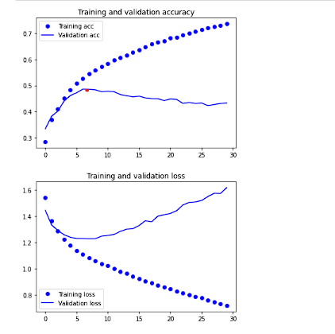

as we can see the overfitting still occurred at 6-7 epochs, but the highest validation acc was higher than that of the model with 32 filters (0.486 vs 0.472)

|  |  |  |
| --- | --- | --- |
| **filter** | **graph showing overfit epoch + brief desc** | **highest val acc** |
| 64/64 | over fits at epoch 5 | 0.49 |
| 8/8 | overfits at 12 | 0.4774 |
| **16/8** | overfits at 12 | 0.485 |
| **8/16** | overfit 9 | 0.45 |
| **128/128** | **overfit 5** | **0.482** |
| **128/64** | **overfit instantly** | **0.4532** |
| **64/128** | **overfit at 4** | **0.4791** |

**Dropout**

from the previous section the best model was the one with 2 lstm layers with both having 64 for their filters, we shall add drop out layers and test their effects on the model

model = Sequential()

model.add(Embedding(max_words,16,input_length =maxlen))

model.add(LSTM(64,return_sequences=True))

model.add(Dropout(0.5))

model.add(LSTM(64))

model.add(Dropout(0.5))

model.add(Dense(5,activation='softmax'))

model.compile(loss='categorical_crossentropy',optimizer='rmsprop',metrics=['acc'])

model.summary()

|  |  |  |
| --- | --- | --- |
| **dropout** | **graph + desc** | **highest val acc** |
| **0.5/0.5** | **overfit at 1** | **0.4817** |
| **0.35/0.35** | **overfit at 6** | **0.476** |
| **0.15/0.5** | **overfit at 9** | **0.4834** |

**Regularization**

Next i moved on to testing regularization, from the previous section, the best model is :

model = Sequential()

model.add(Embedding(max_words,16,input_length =maxlen))

model.add(LSTM(64,return_sequences=True))

model.add(Dropout(0.15))

model.add(LSTM(64))

model.add(Dropout(0.5))

model.add(Dense(5,activation='softmax', kernel_regularizer=regularizers.l1(0.01)))

model.compile(loss='categorical_crossentropy',optimizer='rmsprop',metrics=['acc'])

model.summary()

and now we will add regularizers to the above layers

|  |  |  |
| --- | --- | --- |
| regularizer | graph | best val acc |
| l1(0.01) | overfits at 14 epochs | 0.4834 |
| l2(0.01) |  | 0.4851 |
| l1l2(0.01,0.01) |  | 0.47 |

As we can see, highest validation accuracy did not increase when using regularizers. the fit of the models were still overfitting, this means that regularizers were not useful

**optimizers**

From above we can see that regularizers didn't help, so the model we will be testing the optimizers on is

model = Sequential()

model.add(Embedding(max_words,16,input_length =maxlen))

model.add(LSTM(64,return_sequences=True))

model.add(Dropout(0.15))

model.add(LSTM(64))

model.add(Dropout(0.50))

model.add(Dense(5, activation='softmax'))

model.compile(loss='categorical_crossentropy',optimizer='rmsprop’',metrics=['acc'])

model.summary()

|  |  |  |
| --- | --- | --- |
| adam |  | 0.468 |
| nadam  (learning_rate=0.002, beta_1=0.9, beta_2=0.999, epsilon=None, schedule_decay=0.004) |  | 0.4672 |
| SGD |  |  |

As we can see from above, the optimizers all didnt help, the best was still rmsprop, the fits of the models were all bad.

I also did testing for the conv1d models as well as bidirectional gru, however my jupyter notebook got corrupted and I could not get the outputs in time, but from what was observed when i first tested, the accuracies from the conv1d models as well as the gru models were no where close to that of the lstm

# Model Evaluation using Testing Data (Group)

## 4.1. Analyze different models performance using testing data

To test the models from each groupmate, I first had to get their h5 files for their best model via whatsapp, I then loaded them into the jupyter notebook

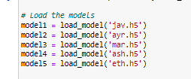

To standardize, I made sure that training for all the models received were stopped before overfitting occurred, this was to ensure the best performance

I then used the evaluate function to evaluate each model against the test data

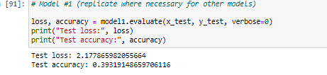

The result shows us the loss as well as the test accuracy.

|  |  |  |  |
| --- | --- | --- | --- |
| name | test loss | test accuracy | graph |
| Ethan | 1.225 | 0.463 |  |
| Javier | 1.322 | 0.43447 |  |
| Ash | 1.37 | 0.409 |  |
| Ayrton | 1.423 | 0.46 |  |
| Marcus | 1.36 | 0.46 |  |

## 

## 4.3. Compare and discuss model’s performance

When comparing different models, there are a few things to take into consideration, we firstly need to look at the fit of the model using the accuracy as well as loss plot, when the model is overfitted (val acc strays away from acc or val loss strays away from loss) we need to stop it before it overfits to get a perfect fit. Then, once we made sure all the models were fitted properly, we can compare the validation acc scores as well as the loss, the best model will have high values and low values for validation acc and loss respectively. Ultimately, the best model will perform the best on the test set.

## 4.3.5 Ensemble modeling

Ensembling is a powerful technique in machine learning that can help improve the accuracy of your model by combining the predictions of multiple models.

The basic idea behind ensembling is to create multiple models, each with its own strengths and weaknesses, and then combine their predictions to produce a more robust and accurate prediction. By combining the predictions of multiple models, ensembling can reduce the impact of individual errors, making the final prediction more reliable.

For example, imagine you have two models that were trained on the same data. Model A might perform well on one type of data but poorly on another, while Model B might perform well on the second type of data but poorly on the first. By combining these models into an ensemble, you can reduce the impact of these individual errors and produce a more accurate prediction.

Ensembling can also help improve the robustness of your model by reducing the risk of overfitting. Overfitting occurs when a model becomes too complex and learns the noise in the training data instead of the underlying patterns. By combining the predictions of multiple models, ensembling can reduce the impact of overfitting and produce a more robust prediction.

Overall, ensembling is a powerful technique that can help improve the accuracy of your models by combining the strengths of multiple models and reducing the impact of individual errors and overfitting.

In a final attempt to increase our models performance, we decided to perform ensemble modeling where we chose our top 3 models and combined them into one ensemble.

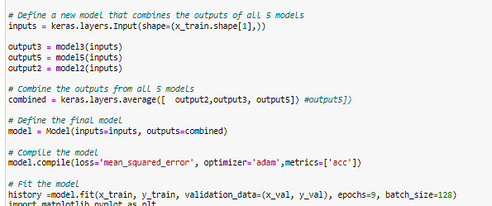

## 4.4. Recommend the best model and why

After comparing each of my teammates' models, we chose the model with the best performance on the test set as well as those that were not severely overfitted. The reason why we prioritize the test set accuracy is because it shows us the performance of the model on unseen data.

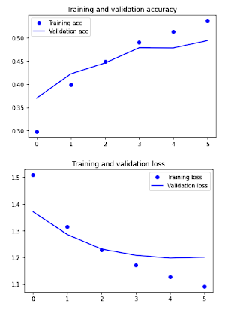

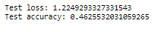

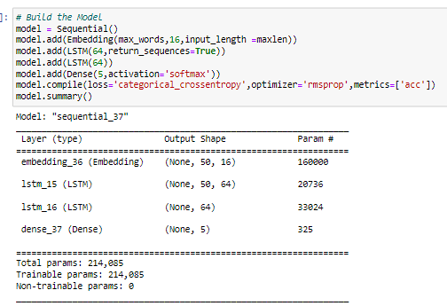

# Use the Best Model to Make Prediction (Group)

## 5.1. How to apply the model on a real-life text input

To apply the model on real-life text input, our group decided to search for an app in a similar category, in this case it could be hbo max, another streaming app, and we use one of the reviews as the input. To make sure the string input could be used by the model, we need to apply the same preprocessing techniques used on the original dataset. So we had to remove stopwords, make it lowercase, remove numbers etc. We also had to split the string into a list of individual words to apply the tokenizer. Once this was done, the model was able to use the input as predictions.We apply the model to various reviews, varying in the review score. This helps to explore how the model performs on the different review scores available. This will tell us what our model is lacking in, in terms of the feature extraction process.

By exposing our model to real-life inputs, it helps to gauge how well our model can perform in a real-world context instead of just depending on the validation and test data which is still retrieved from the same dataset as our train data. Additionally, this test the model’s robustness in the real-world context where the app’s reviews might contain variations in language, tone, and expression that can make sentiment analysis challenging. By applying sentiment analysis models to real-world inputs, we can test their robustness and make them more resilient to these variations.

## 5.2. Explain and analyze the model prediction

So for the model prediction , I took 2 reviews from HBO, a similar streaming application.

Firstly I inputted a 5 star review’s content, as can be seen from below the model did a moderate job in predicting the correct class, it predicted the review as class 5 with a 70% accuracy. When we see the class 4 predictions being the 2nd highest confidence, it is a good thing as we can see that the model is able to understand which words are positive.

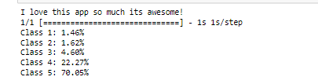

However, when inputting a 1 star review, we can see that the model has a very rough time predicting the correct class. This means that our model cannot distinguish between negative sentiment and positive sentiment. There might be a reason for this, it is common to represent a negative feeling by adding a negative word and a positive word, for example not good, the might confuse the model as the model might not be able to detect this pattern. I think we could have done additional data preprocessing to fix this.

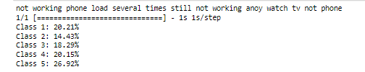

# Summary (Group)

## 6.1. Summarize model performance and provide suggestions for further improvement

The model performance was evaluated by taking reviews from similar apps as the ones we chose for this assignment. In this case, we chose to take 2 reviews from HBO, 1 5 star review, and 1 1 star review. 

Figure 1.1: Prediction on 5 star review



Figure 1.2: Prediction on 1 star review

Based on figure 1.1 and 1.2, the model does well on positive 5 star reviews, with a very high of confidence of 70.05%. While on the other hand, the model does badly when it comes to negative 1 star reviews. This is seen from the almost equally distributed confidence for all the different review scores. This means that our model needs more words with negative sentiment. However, since we applied stratified sampling, it just means that the model required more training data. This is concluded from the fact that all of our models overfit very early on despite applying almost every overfitting technique possible. Thus another solution that was attempted but failed was to perform data augmentation. Text data augmentation has methods like random insertion, random deletion, and random swap to generate more text data for the model to train. Thus, another way to improve future models is to instead of only looking at changing model parameters to deal with overfitting, other approaches like changing the data should be attempted as well. We also could look into different approaches for the architecture of our model as the model can be changed to improve its performance. For example, we can try and test with different layers for better optimisation. We can also try to start the training earlier and try to implement the idea of ensemble models more. Since ensemble models involves the combining of predictions from multiple models to produce a more accurate result, it is definitely an step that we can try to take towards improvement. By doing this, this also help reduce overfitting and improve the robustness of the model. Another option that we can explore is performing feature engineering, The quality of the input features used to train a model can have a big impact on its performance. Feature engineering is the process of creating new features from raw data, or transforming existing features to make them more suitable for a particular model.

# 

## 